**Practical 1**

**Aim:(i) Create tables according to the following definition**

**TABLE 1: Salespeople**

**Code :**

create table Salespeople (Snum number(10), sname varchar(50), city varchar(50), comm decimal(20,20))

desc Salespeople

insert into Salespeople values(1001,'Peel','London',0.12)

insert into Salespeople values(1002,'Serres','San jose',0.13)

insert into Salespeople values(1003,'Axelord','New York',0.10)

insert into Salespeople values(1004,'Motika','London',0.11)

insert into Salespeople values(1005,'Rifkin','Barcelona',0.15)

select *from Salespeople

**Output:**

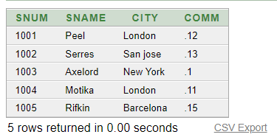

**TABLE 2: Customer**

**Code :**

create table Customer(Cnum number(10), Cname varchar(50), City varchar(50), Raking number(10), Snum number(10))

desc Customer1

insert into Customer values(2001,'Hoffman','London',100,1001)

insert into Customer values(2002,'Giovamne','Rome',200,1003)

insert into Customer values(2003,'Liu','San jose',300,1002)

insert into Customer values(2004,'Grass','Berlin',100,1002)

insert into Customer values(2006,'Clemens','London',300,1007)

insert into Customer(Cnum, Cname, Raking, Snum) values(2007,'Pereria',100,1004)

select *from Customer

**Output:**

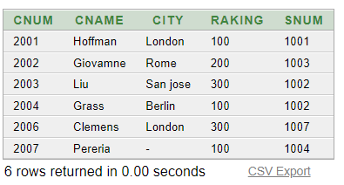

**TABLE 3: Orders**

**Code :**

create table Order(Onum number(10), Amount number(4,2), Odate date, Cnum number(10), Snum number(10))

desc Order

insert into Order values(3001,18.96,'10-MAR-2008',2002,1002)

insert into Order values(null,null,null,null,null)

insert into Order values(null,null,null,null,null)

select *from Order

**Output :**

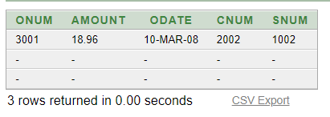

* **Based on the given table perform following queries:**

1. **Display snum, sname, city and comm. Of all salespeople.**

**Query : select *from Salespeople**

**Output:**

1. **Display all snum without duplicates from all orders.**

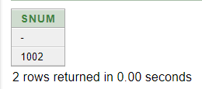**Query: select distinct Snum from Order4**

**Output:**

1. **Display names and commissions of all salespeople from London.**

**Query: select sname, comm from Salespeople where city = 'London'**

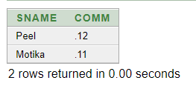**Output:**

1. **All customers with a rating of 100.**

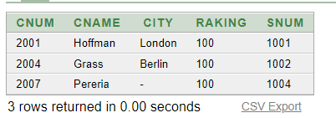**Query : select *from Customer1 where Raking = 100**

**Output:**

1. **Produce order no, amount and date for all rows in the order table.**

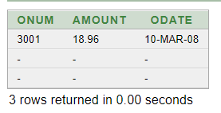**Query: select Onum, Amount, Odate from Order4**

**Output:**

1. **All customers who were either located in San Jose or had a rating above $200.**

**Query:** **select *from Customer1 where Raking>200 or city = 'San jose'**

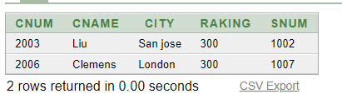**Output :**

1. **All customers in San Jose, who have a rating > 200.**

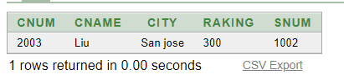**Query : select *from Customer1 where Raking>200 and city = 'San jose'**

**Output:**

1. **All orders for more than $1000.**

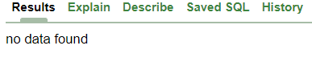**Query: select *from Order4 where Amount>1000**

**Output:**

1. **Names and cities of all salespeople in London with a commission above 0.10.**

**Query:** **select sname, city from Salespeople where comm>0.10**

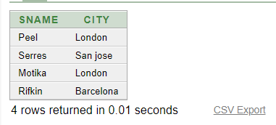 **Output:**

1. **All customers excluding those with rating <= 100 unless they are located in Rome.**

**Query:** **select *from Customer1 where Raking>100 or city = 'Rome'**

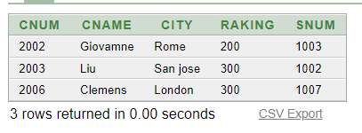**Output:**

1. **All salespeople either in Barcelona or in London.**

**Query:** **select *from Salespeople where city in('Barcelona' ,'London')**

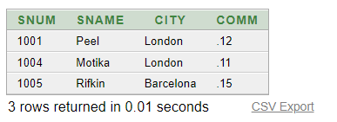**Output:**

1. **All customers without a city.**

**Query: select *from Customer1 where city is null**

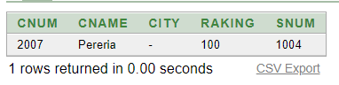**Output:**

1. **All orders taken on oct. 3rd or 4th 1994.**

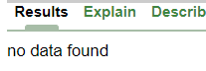**Query: select *from Order4 where Odate between '03-OCT-1994' and '04-OCT-1994'**

**Output:**

**ii)Write the following simple SQL Queries on the University Dataset:**

1. **Find the names of all the students whose total credits are greater than 100**

Query:select name from student where total credits > 100

**2.Find the course id and grades of all courses taken by any student named 'Tanaka'**

Query: select id, grades from courses where student = ‘Tanaka’

**3.Find the ID and name of instructors who have taught a course in the Comp. Sci. department, even if they are themselves not from the Comp. Sci. department. To test this query, make sure you add appropriate data and include the corresponding insert statements along with your query.**

Query: select id , name from course where department = ‘Computer Science Department’

**4.Find the courses which are offered in both 'Fall' and 'Spring' semester (not necessarily in the same year).**

Query:select courses from record where semester = ‘Fall’ and semester = ‘Spring’

**CONCLUSION:** In this practical I learned about creating tables using SQL commands and select query.

**Staff Signature:**

**Grade:**

**Remarks by the Staff:**

**Practical 2**

**Aim:(i) Create the below given table and insert the data accordingly.**

**Create Table Job (job_id, job_title, min_sal, max_sal)**

**Code :**

create table job(job_id varchar2(15),job_title varchar2(30), min_sal number(7,2),max_sal number(7,2))

insert into job values('it_prog','Programmer',4000,10000)

insert into job values('mk_mgr','Marketing manager',9000,15000)

insert into job values('fi_mgr','Finance manager',8200,12000)

insert into job values('fi_acc','Account',4200,9000)

insert into job values('lec','Lecturer',6000,17000)

insert into job values('comp_op','Computer Operator',1500,3000)

select * from job

**Output:**



**Create table Employee (emp_no, emp_name, emp_sal, emp_comm, dept_no, l_name, dept_name, job_id, location, manager_id, hiredate) and insert following values in the table Employee.**

**Code:**

create table employee(emp_no number(3),emp_name varchar2(30),emp_sal number(8,2),emp_comm number(6,1),dept_no number(3), l_name varchar2(30), dept_name varchar2(30), job_id varchar2(15), location varchar2(15), manager_id number(5), hiredate date)

insert into employee values(101,'Smith',800,'',20,'shah','machine learing','fi_mgr','toronto',105,'09-aug-96')

insert into employee values(102,'Snehal',1600,300,25,'gupta','data science','lec','las vegas','','14-mar-96')

insert into employee values(103,'Adama',1100,0,20,'wales', 'machine learing', 'mk_mgr','ontario', 105, '30-nov-95')

insert into employee values(104,'Aman',3000,'',15,'sharma','virtual reality','comp_op','mexico',12,'02-oct-97')

insert into employee values(105,'Anita',5000,50000,10,'patel','big data analysis','comp_op','germany', 107,'01-jan-98')

insert into employee values(106,'Sneha',2450,24500,10,'joseph','big data analytics','fi_acc', 'melbourne', 105,'26-sep-97')

insert into employee values(107,'Anamika',2975,'',30,'jha','artificial intelligence','it_prog','new york', '','15-jul-97')

select * from employee

**Output:**

  
  
**Create table deposit(a_no,cname,bname,amount,a_date) and Insert following values in the table deposit.**

**Code:**

create table deposit(a_no varchar2(5), cname varchar2(15),bname varchar2(10),amount number(7,2),a_date date)

insert into deposit values(101,'Anil','andheri',7000,'01-jan-06')

insert into deposit values(102,'Sunil','virar',5000,'15-jul-06')

insert into deposit values(103,'Jay','villeparle',6500,'12-mar-06')

insert into deposit values(104,'Vijay','andheri',8000,'17-sep-06')

insert into deposit values(105,'Keyur','dadar',7500,'19-nov-06')

insert into deposit values(106,'Mayur','borivali',5500,'21-dec-06')

select *from deposit

**Output:**



**Create table borrow (loanno, cname, bname, amount).**

**Code:**

Create table borrow (loanno varchar2(5), cname varchar2(15), bname varchar2(10), amount number(7,2))

**Output:**



**Perform following queries**

(1) Retrieve all data from employee, jobs and deposit.

**Query:** select *from job

**Output:**

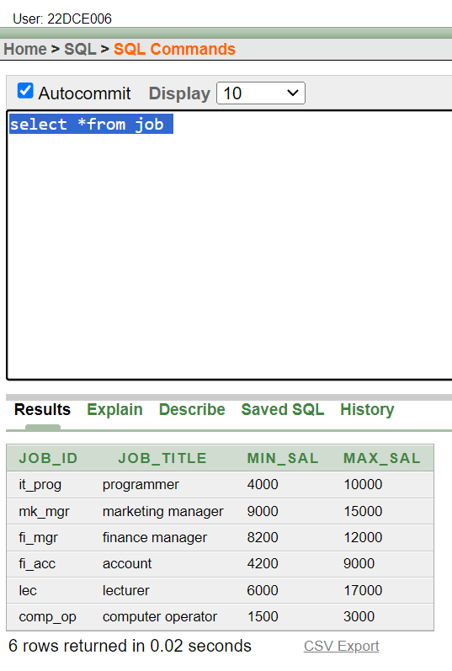

**Query:** select *from employee

**Output:**

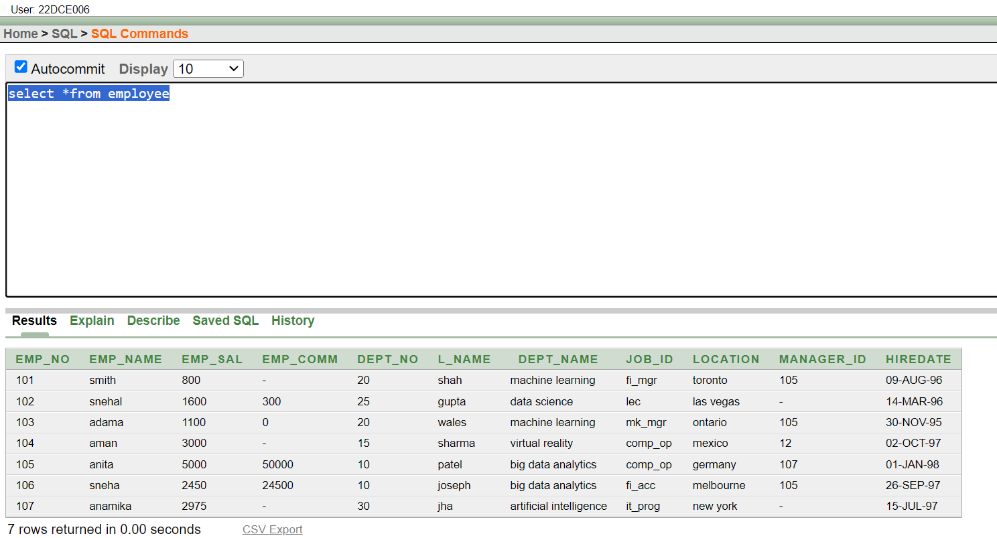

**Query:** select *from deposit

**Output:**

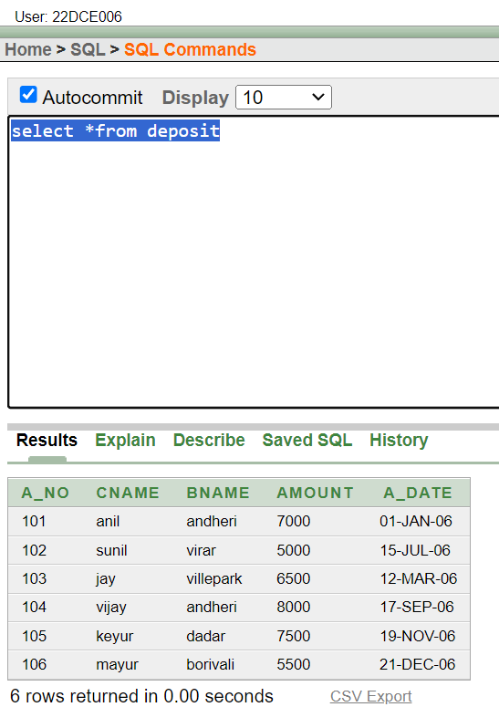

(2) Give details of account no. and deposited rupees of customers having account opened between dates 01-01-06 and 25-07-06.

**Query:** select a_no,amount from deposit where a_date between '01-jan-06' and '25-jul-06'

**Output:** 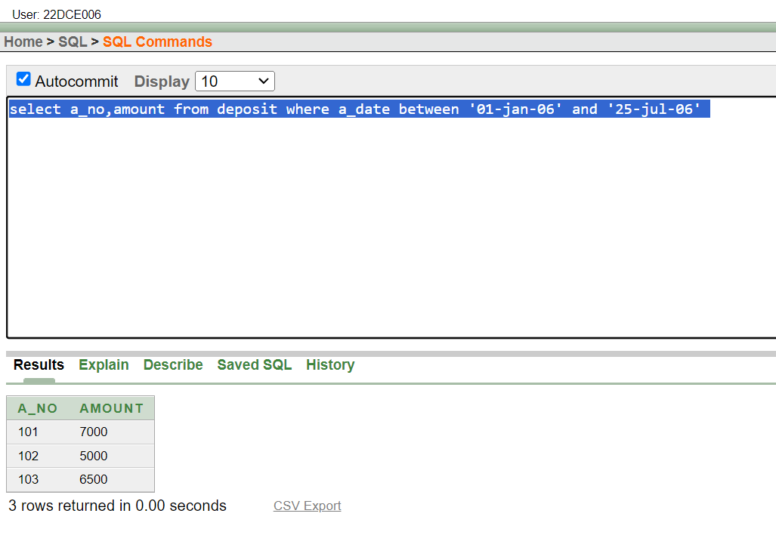

(3) Display all jobs with minimum salary is greater than 4000.

**Query:** select *from job where min_sal>4000

**Output:**

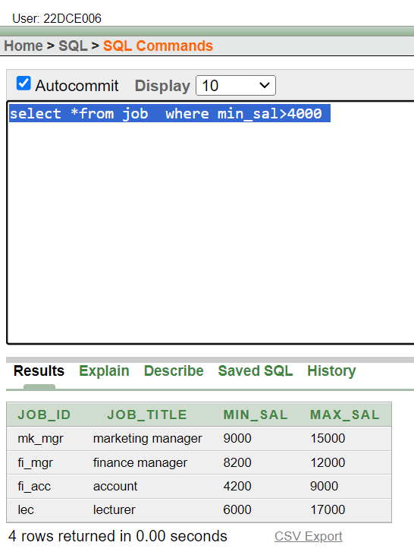

(4) Display name and salary of employee whose department no is 20. Give alias name to name of employee.

**Query:** select emp_name "Employee Name", emp_sal "Employee Salary" from employee where dept_no=20

**Output:**

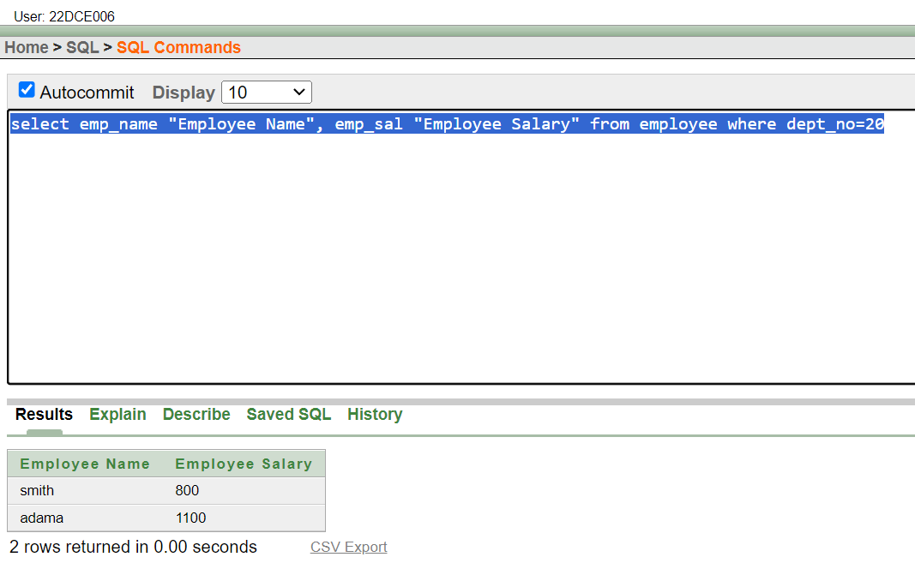

(5) Display employee no, name and department details of those employee whose department lies in (10,20).

**Query:** select emp_no,emp_name,dept_no,dept_name from employee where dept_no between 10 and 20

**Output:**

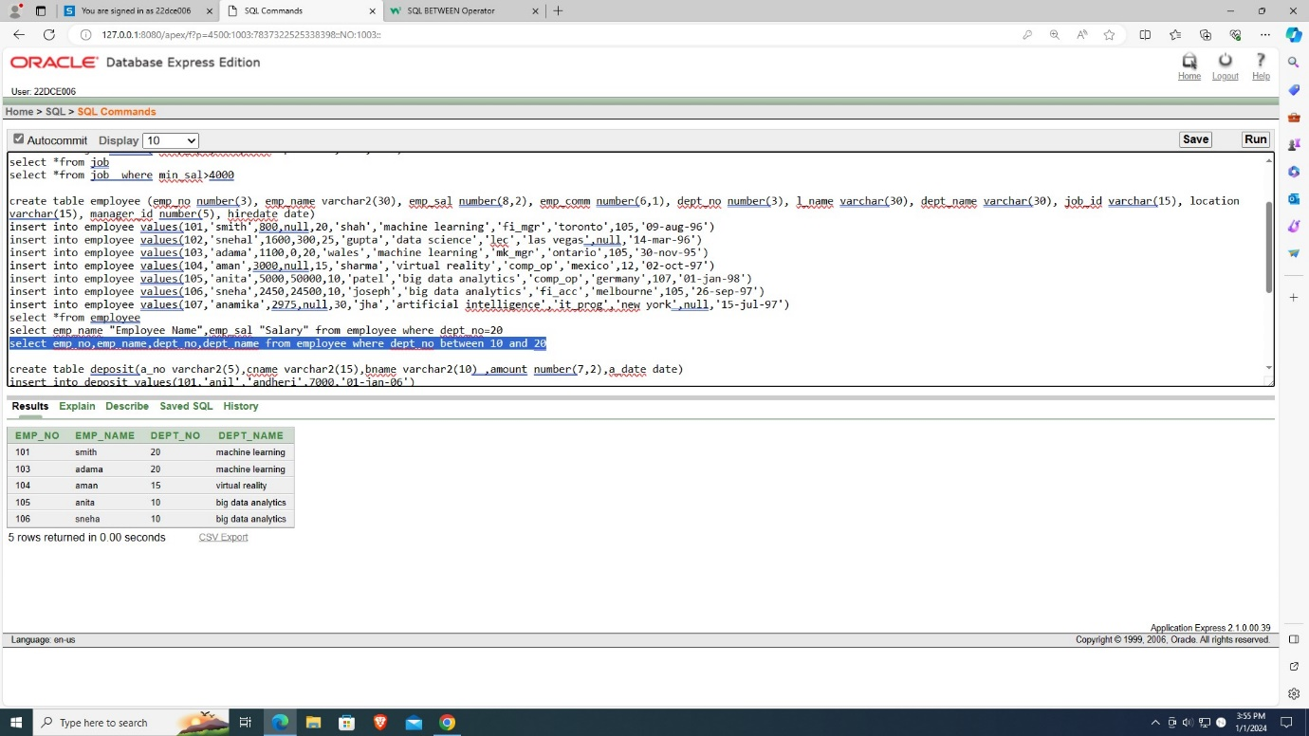

(6) Display the non-null values of employees.

**Query:** select *from employee where emp_comm is not null

**Output:**

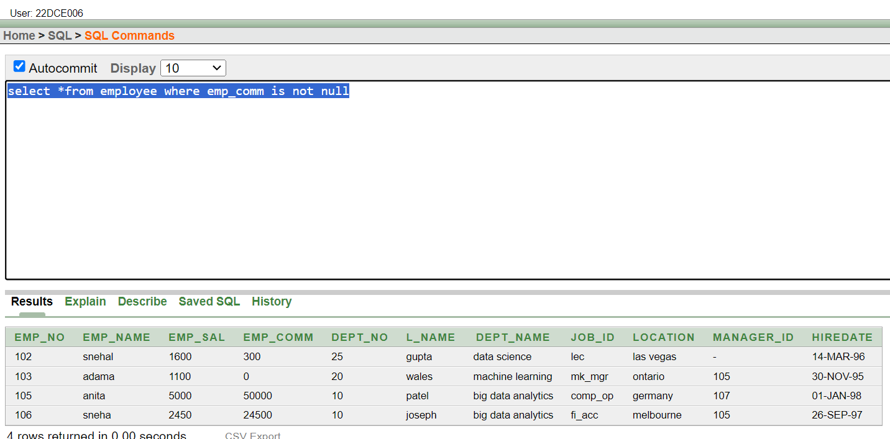

(7) Display name of customer along with its account no (both columns should be displayed as one) whose amount is not equal to 8000 Rs.

**Query:** select cname ||' '|| a_no "Name and AccountNumber"from deposit where amount!=8000

**Output:**

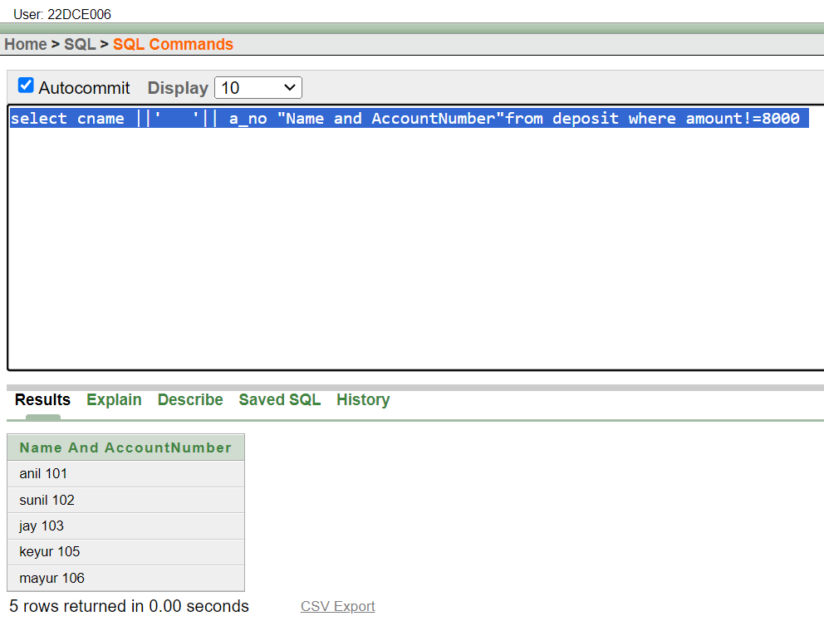

(8) Display the content of job details with minimum salary either 2000 or 4000.

**Query:** select *from job where min_sal = 2000 or min_sal = 4000

**Output:**

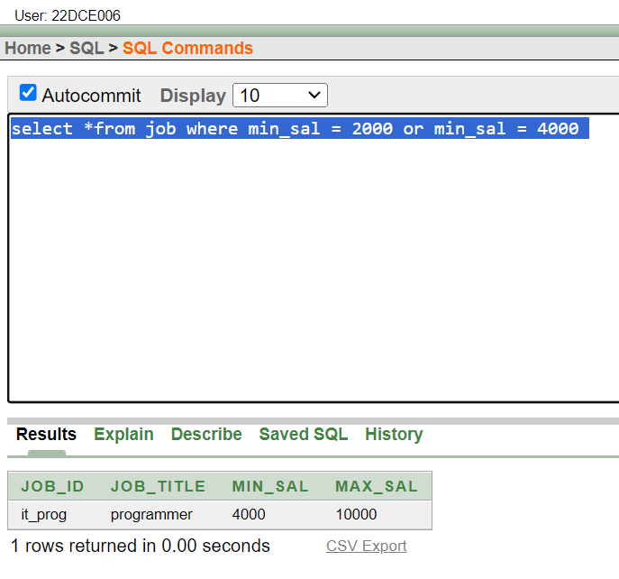

**To study various options of LIKE predicate**

(1) Display all employee whose name start with ‘A’ and third character is ‘‘a’.

**Query:** select *from employee where emp_name like 'a_a%'

**Output:**

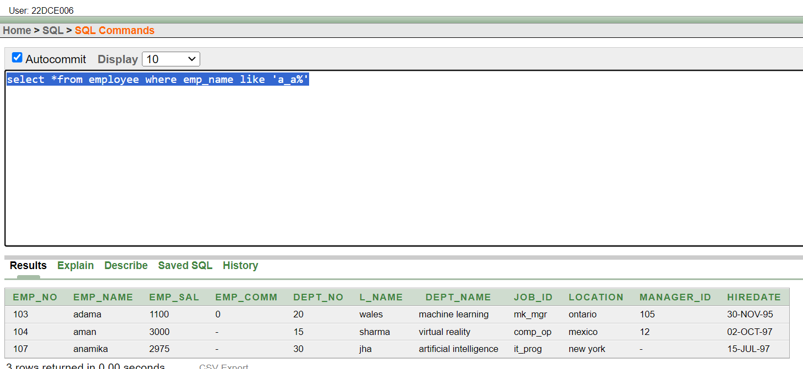

(2) Display name, number and salary of those employees whose name is 5 characters long and first three characters are ‘Ani’.

**Query:** select emp_name,emp_no,emp_sal from employee where emp_name like'ani__'

**Output:**

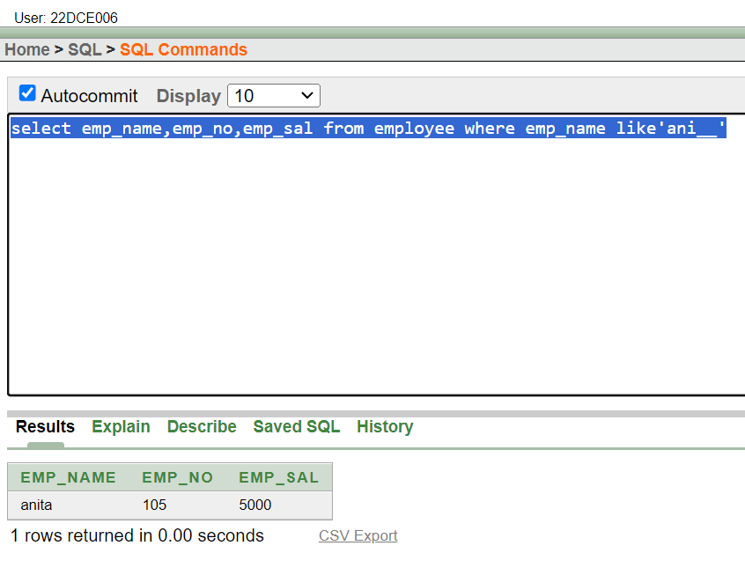

(3) Display all information of employee whose second character of name is either ‘M’ or ‘N’.

**Query:** select *from employee where emp_name like '_m%' or emp_name like'_n%'

**Output:**

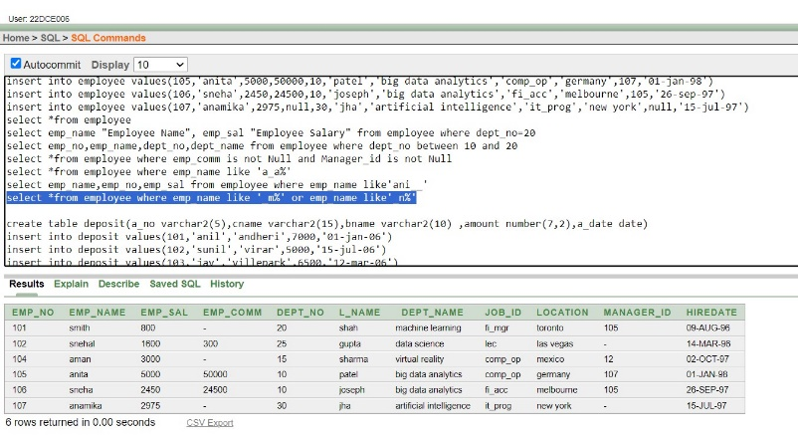

(4) Find the list of all customer name whose branch is in ‘andheri’ or ‘dadar’ or ‘virar’.

**Query:** select cname from deposit where bname='andheri' or bname='virar' or bname='dadar'

**Output:**

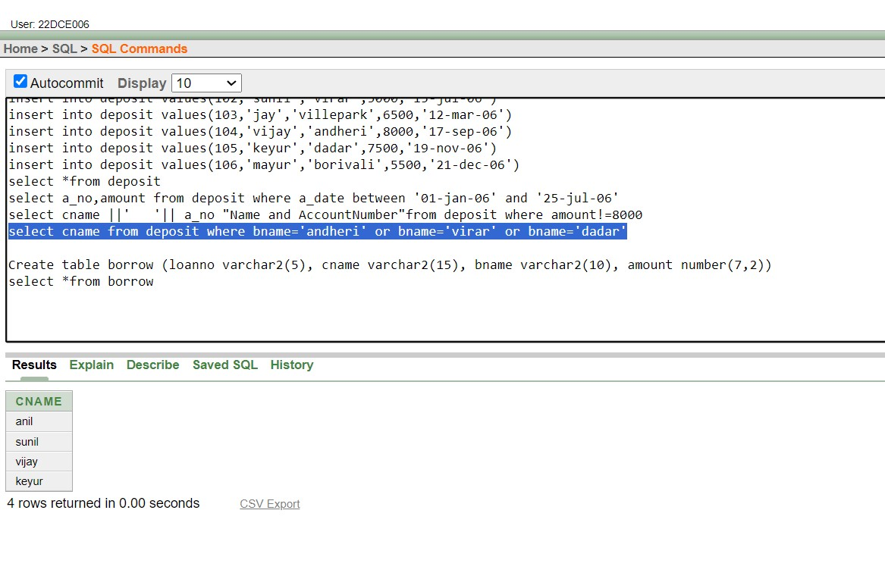

(5) Display the job name whose first three character in job id field is ‘FI_’.

**Query:** select job_title from job where job_id like 'fi$_%' escape '$'

**Output:**

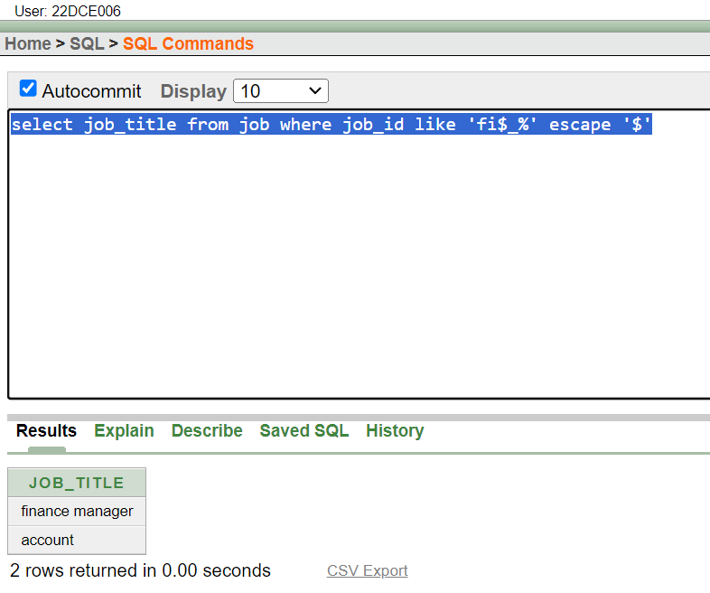

(6) Display the title/name of job who’s last three character are ‘_MGR’ and their maximum salary is greater than Rs 12000.

**Query:** select job_title from job where job_id like '%_mgr' and max_sal>12000

**Output:**

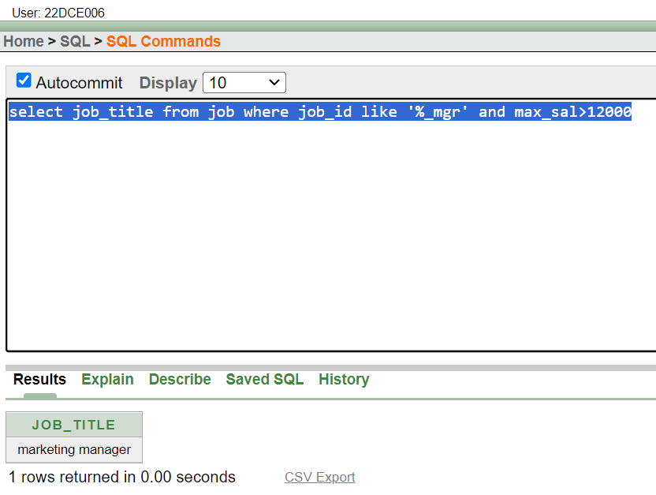

(7) Display the non-null values of employees and also employee name second character should be ‘n’ and string should be 5-character long.

**Query:** select *from employee where emp_comm is not null and emp_name like '_n___'

**Output:**

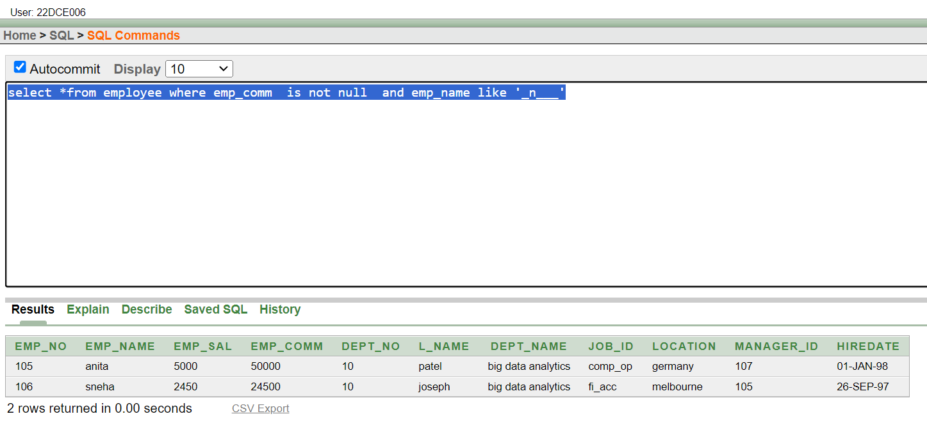

(8) Display the null values of employee and also employee name’s third character should be ‘a’.

**Query:** select *from employee where emp_comm is null and emp_name like '__a%'

**Output:**

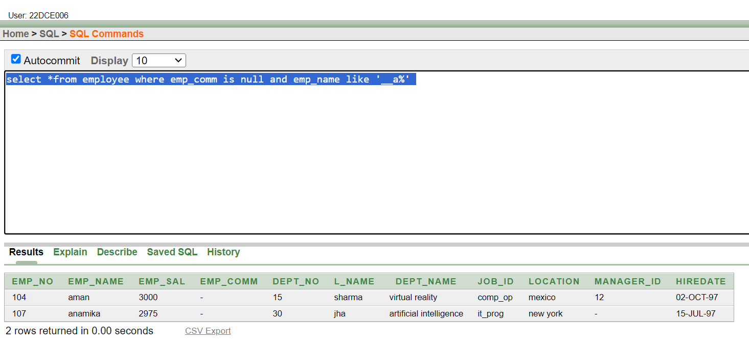

(9) What will be output if you are giving LIKE predicate as ‘%\_%’ ESCAPE ‘\’

**Query:** select *from job where job_id like '%\_%' escape '\'

**Output:**

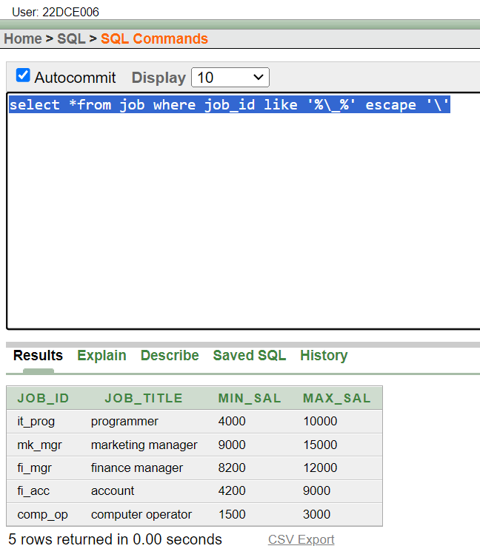

**CONCLUSION:** From this practical, I learned about the use of like predicate and between keyword. Also displaying non null values with the logic of escape characters.

**Staff Signature:**

**Grade:**

**Remarks by the Staff:**

**Practical 3**

**Aim:**

To Perform various data manipulation commands, aggregate functions and sorting concept on all created tables.

(1) List total deposit from deposit.

**Query:** select sum(amount) from deposit

**Output:**

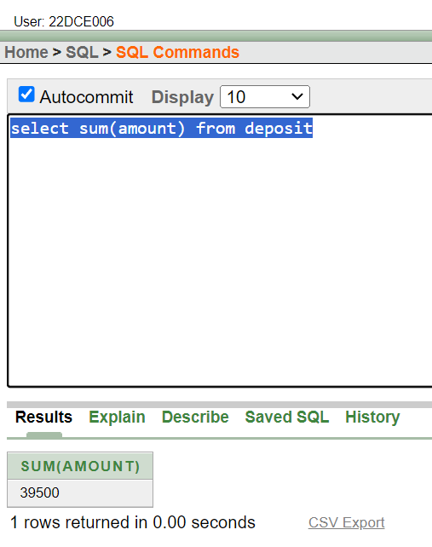

(2) List total loan from karolbagh branch

**Query:** select sum(amount) from deposit where bname='karolbagh'

**Output:**

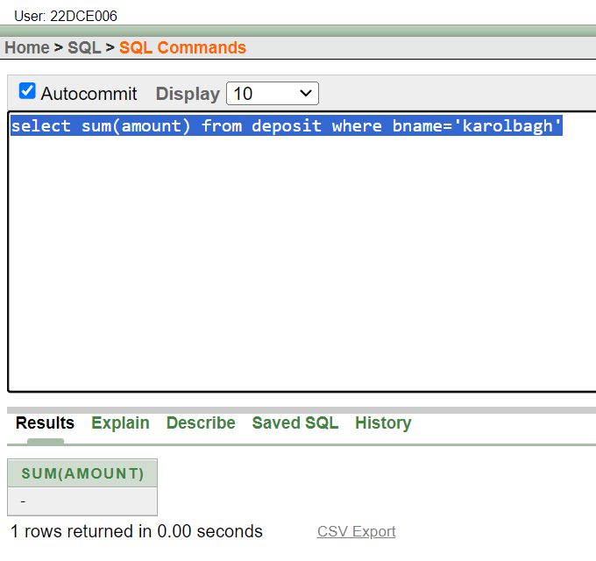

(3) Give maximum loan from branch vrce.

**Query:** select MAX(amount) from deposit where bname='VRCE'

**Output:**

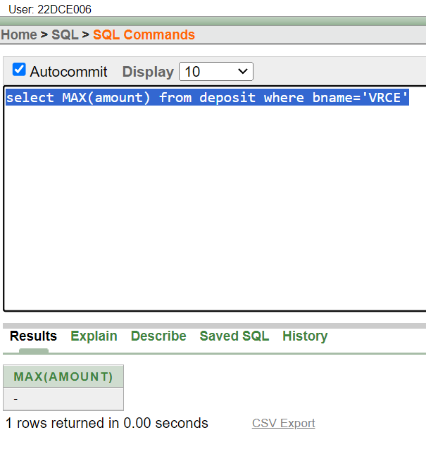

(4) Count total number of customers

**Query:** select count(cname) from Customer

**Output:**

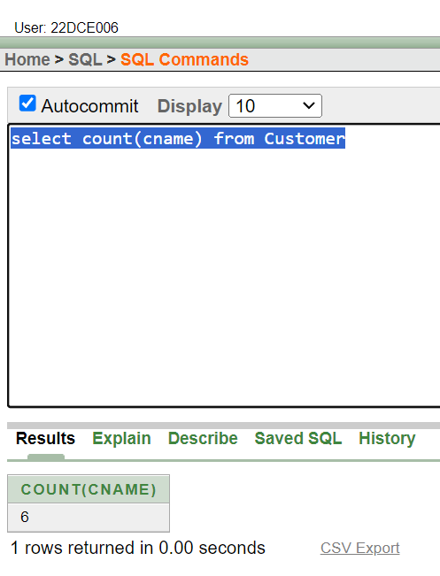

(5) Count total number of customer’s cities.

**Query:** select count(distinct city) from Customer

**Output:**

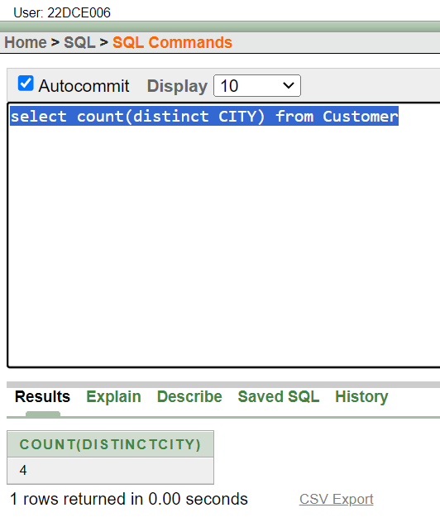

(6) Create table supplier from employee with all the columns.

**Query:** create table supplier as (select * from employee)

**Output:**

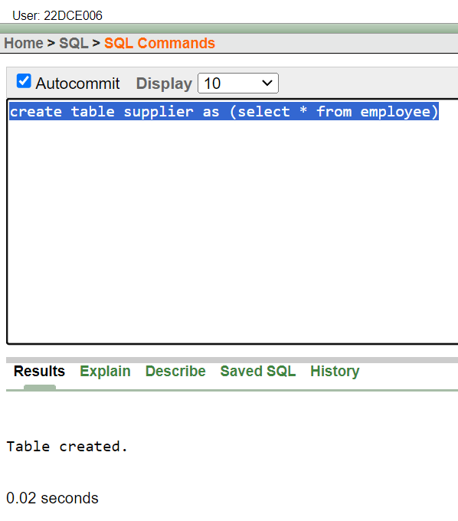

(7) Create table sup1 from employee with first two columns.

**Query:** create table sup1 as (select emp_no,emp_name from employee)

**Output:**

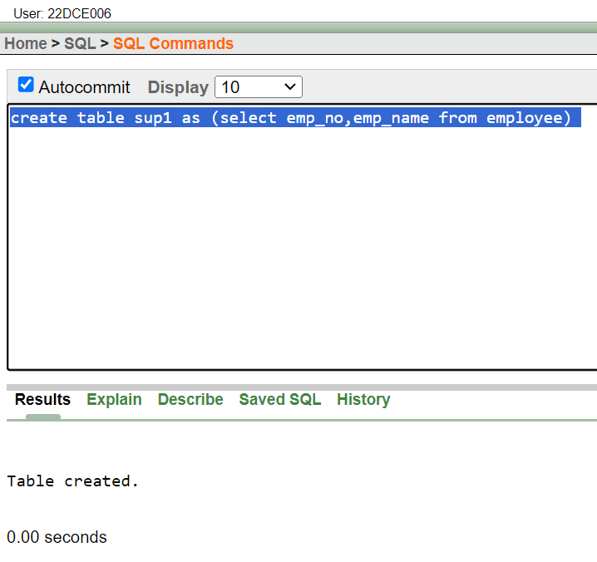

(8) Create table sup2 from employee with no data

**Query:** create table sup2 as (select * from employee where 1=0)

**Output:**

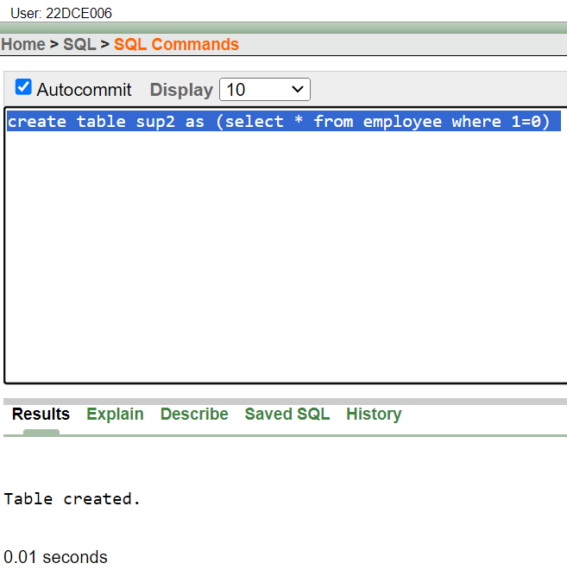

(9) Insert the data into sup2 from employee whose second character should be ‘n’ and string should be 5 characters long

in employee name field.

**Query:** insert into sup2 select *from employee where emp_name like '_n___'

**Output:**

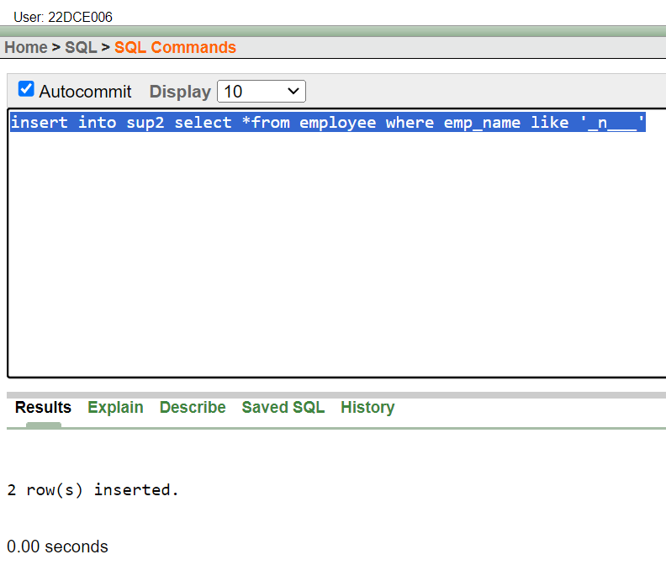

(10) Delete all the rows from sup1.

**Query:** delete sup1

**Output:**

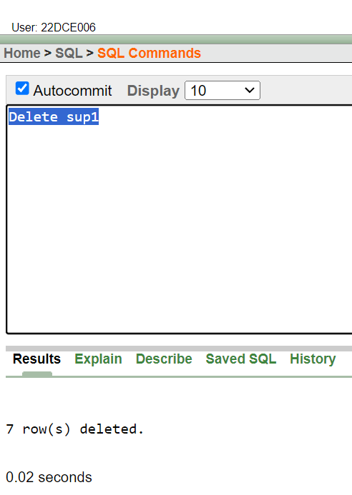

(11) Delete the detail of supplier whose sup_no is 103.

**Query:** delete from supplier where emp_no=103;

**Output:**

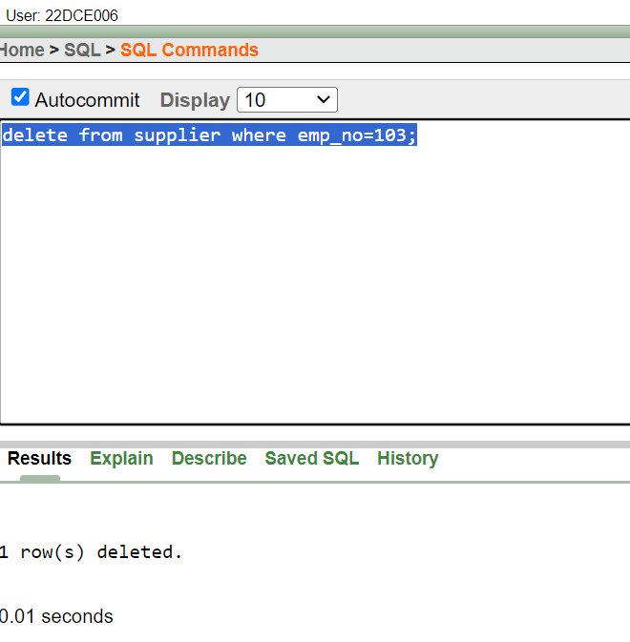

(12) Rename the table sup2.

**Query:** rename sup2 to supply

**Output:**

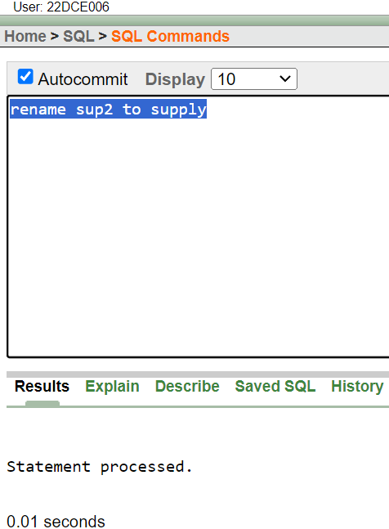

(13) Destroy table sup1 with all the data.

**Query:** drop table sup1;

**Output:**

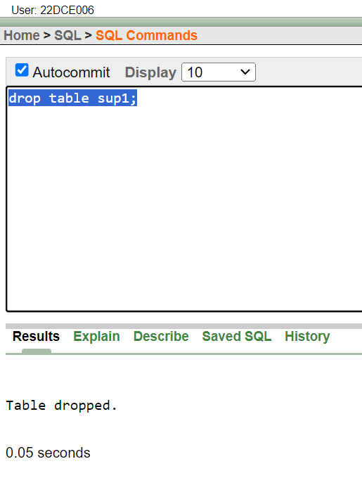

(14) Update the value dept_no to 10 where second character of emp. name is ‘m’.

**Query:** update employee set dept_no=10 where emp_name like '_m%'

**Output:**

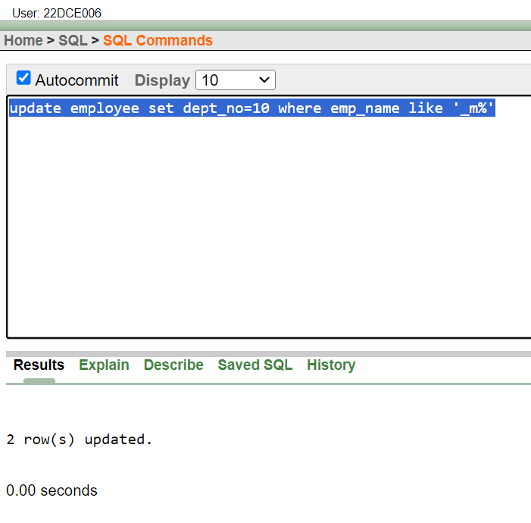

(15) Update the value of employee name whose employee number is 103.

**Query:** update employee set emp_name='David' where emp_no = 103

**Output:**

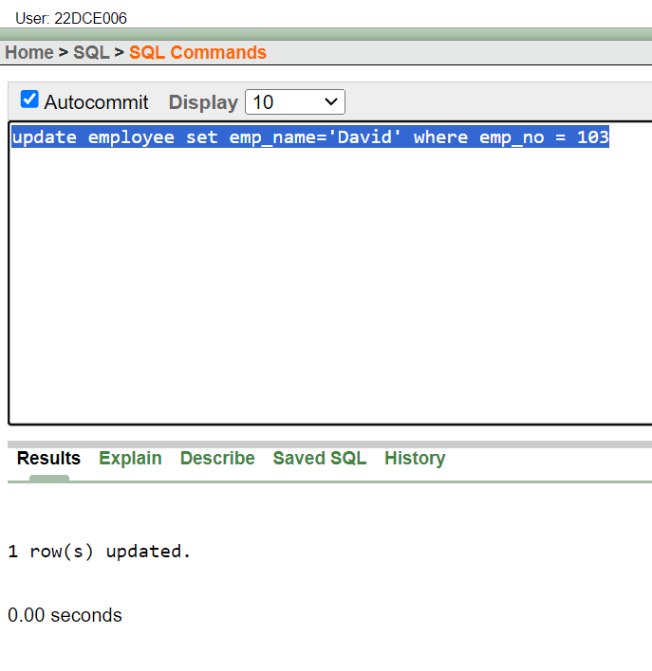

(16) Add one column phone to employee with size of column is 10.

**Query:** alter table employee add phone number(10)

**Output:**

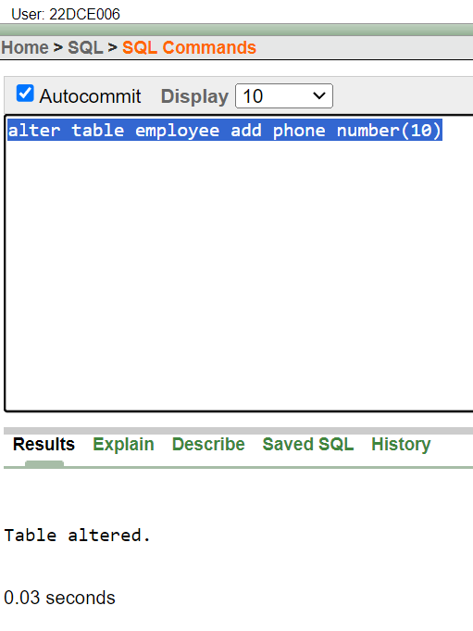

(17) Modify the column emp_name to hold maximum of 30 characters.

**Query:** alter table employee modify emp_name varchar2(30);

**Output:**

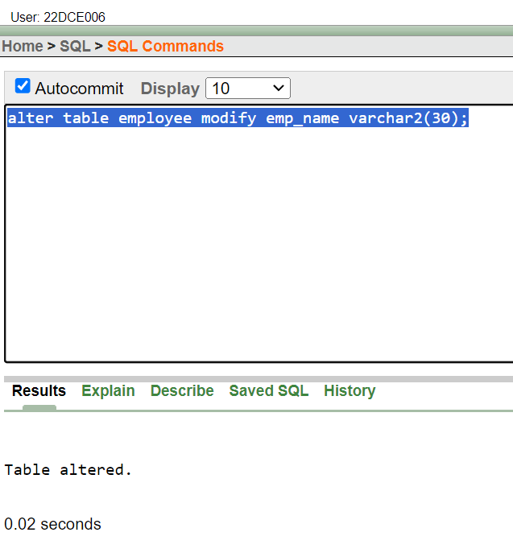

(18) Count the total no as well as distinct rows in dept_no column with a condition of salary greater than 1000 of employee

**Query:** select count(distinct emp_no) from employee where emp_sal>1000

**Output:**

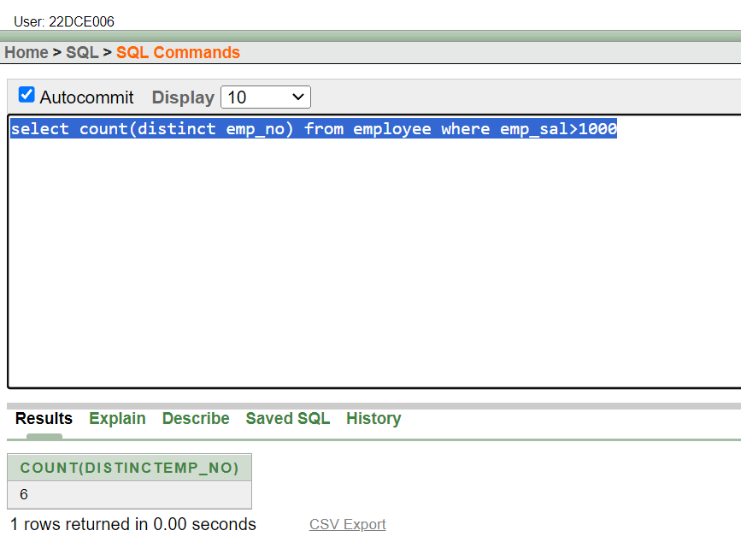

(19) Display the detail of all employees in ascending order, descending order of their name and no.

**Query:** select *from employee order by emp_name asc,emp_no desc

**Output:**

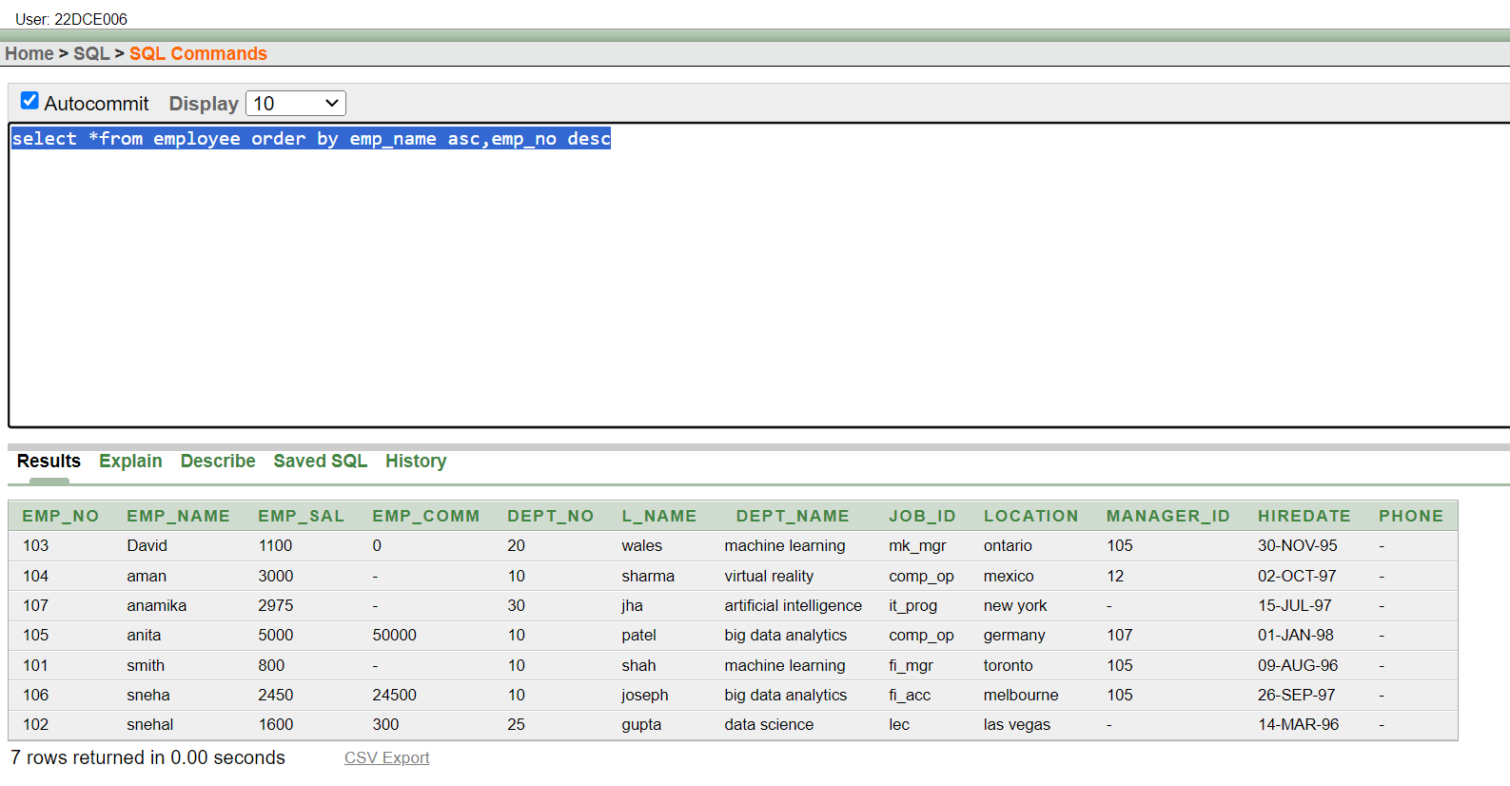

(20) Display the dept_no in ascending order and accordingly display emp_comm in descending order.

**Query:** select *from employee order by dept_no asc,emp_comm desc

**Output:**

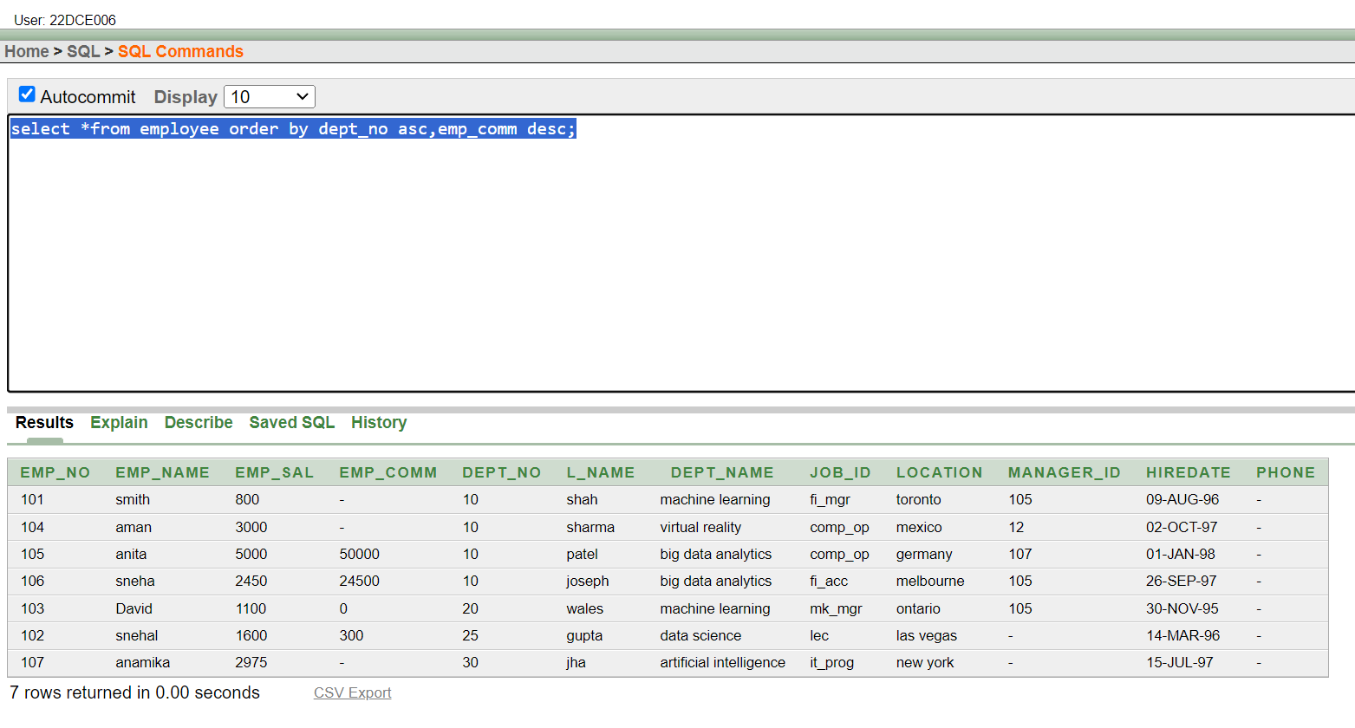

(21) Update the value of emp_comm to 500 where dept_no is 20.

**Query:** update employee set emp_comm=500 where dept_no = 20

**Output:**

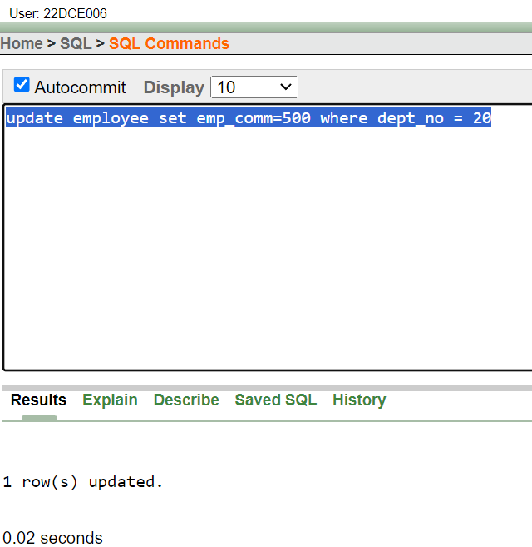

(22) Display the emp_comm in ascending order with null value first and accordingly sort employee salary in descending order.

**Query:** select *from employee order by emp_comm asc nulls first,emp_sal desc

**Output:**

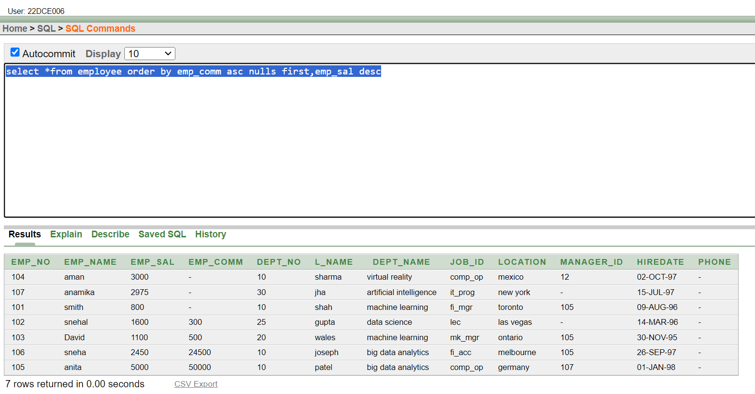

(23) Display the emp_comm in ascending order with null value last and accordingly sort emp_no in descending order.

**Query:** select *from employee order by emp_comm asc nulls last,emp_no desc;

**Output:**

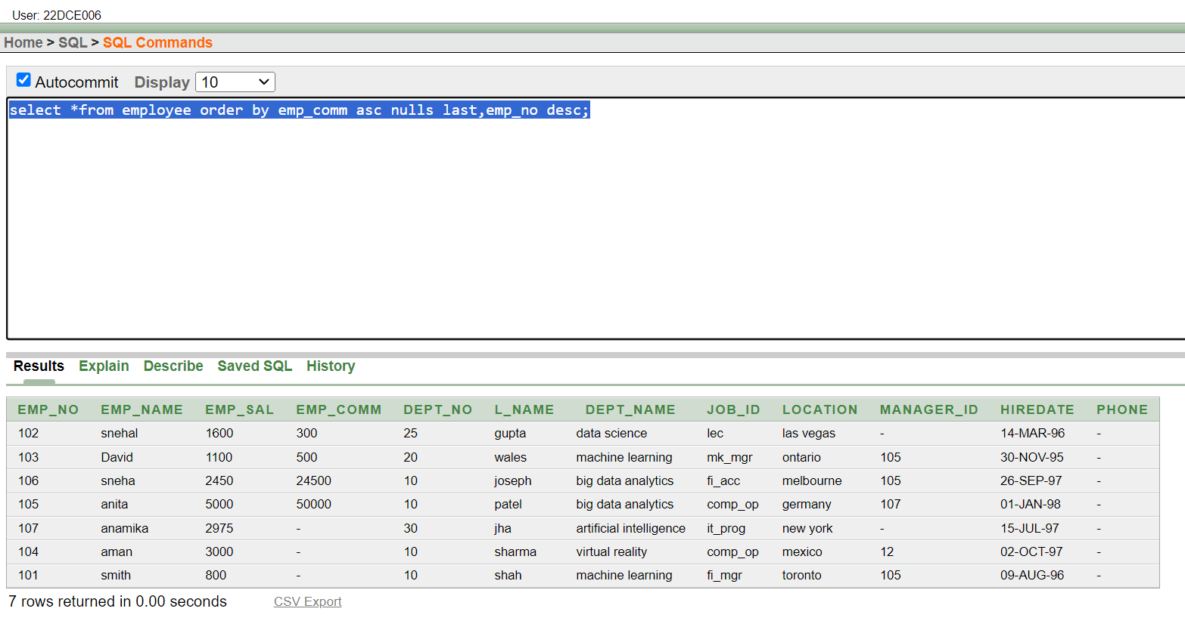

**Conclusion:** From this practical I learned about different SQL commands that can be used for data manipulation and also used for sorting the data according to the requirement.

**Staff Signature:**

**Grade:**

**Remarks by the Staff:**

**Practical 4**

**Aim:**

To Implement Single-row functions.

(1) Write a query to display the current date. Label the column Date

**Query: SELECT SYSDATE as "DATE" FROM dual**

**Output:**

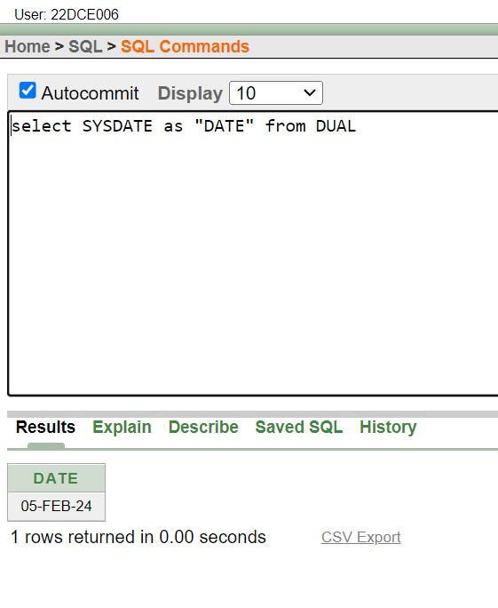

(2) For each employee, display the employee number, salary, and salary increased by 15% and expressed as a whole number. Label the column New Salary

**Query: select emp_name,emp_no,emp_sal,(emp_sal + emp_sal*0.15) AS NEW_SAL from employee**

**Output:**

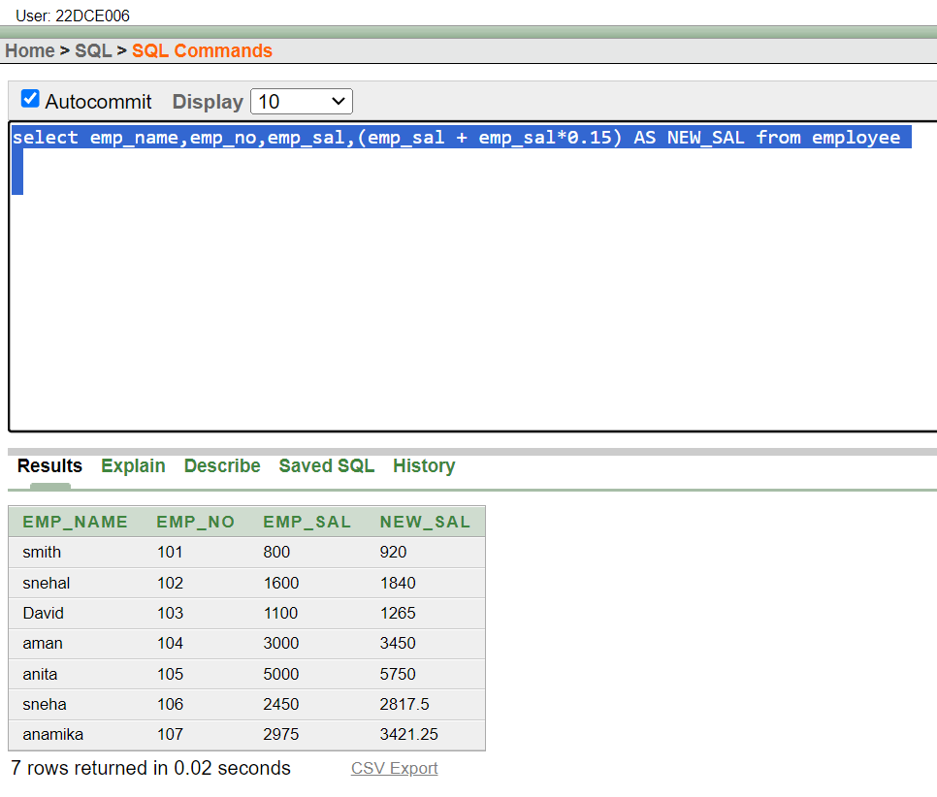

(3) Modify your query no (2) to add a column that subtracts the old salary from the new salary. Label the column Increase

**Query: select emp_name,emp_no,emp_sal,(emp_sal + emp_sal*0.15) AS NEW_SAL,((emp_sal +emp_sal*0.15)-emp_sal) INCREASE_SAL from employee**

**Output:**

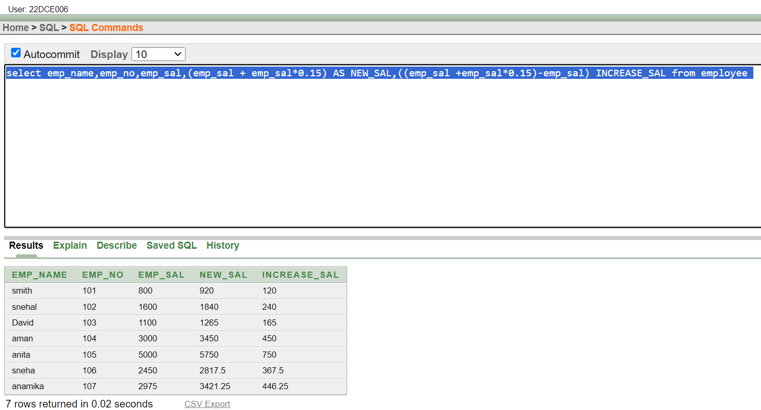

(4) Write a query that displays the employee’s names with the first letter capitalized and all other letters lowercase, and the length of the names, for all employees whose name starts with J, A, or M. Give each column an appropriate label. Sort the results by the employees’ last names.

**Query: select initcap(emp_name) AS EMPLOYEE_NAME,length(emp_name) as NAME_LENGTH from employee where emp_name like 'j%' or emp_name like 'a%' or**

**emp_name like 'm%' order by l_name**

**Output:**

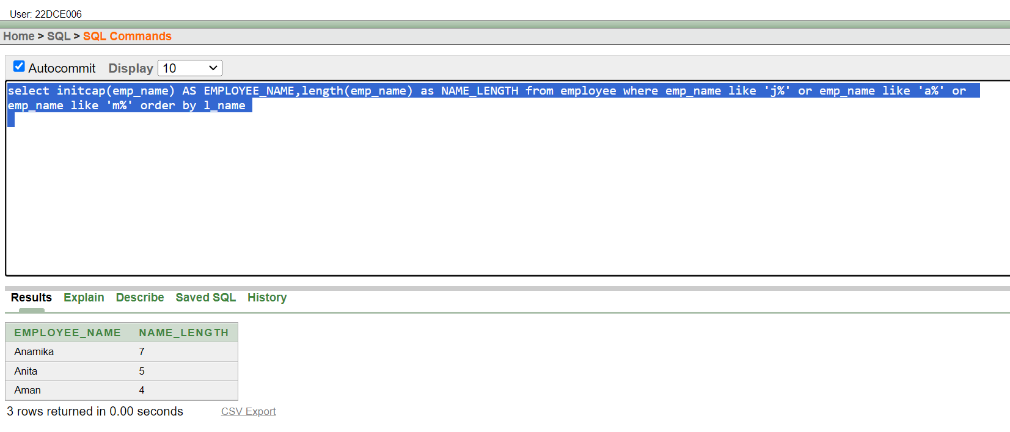

(5) Write a query that produces the following for each employee:

<employee last name> earns <salary> monthly

**Query: select emp_name || ' earns ' || emp_sal as emp_name_sal from employee**

**Output:**

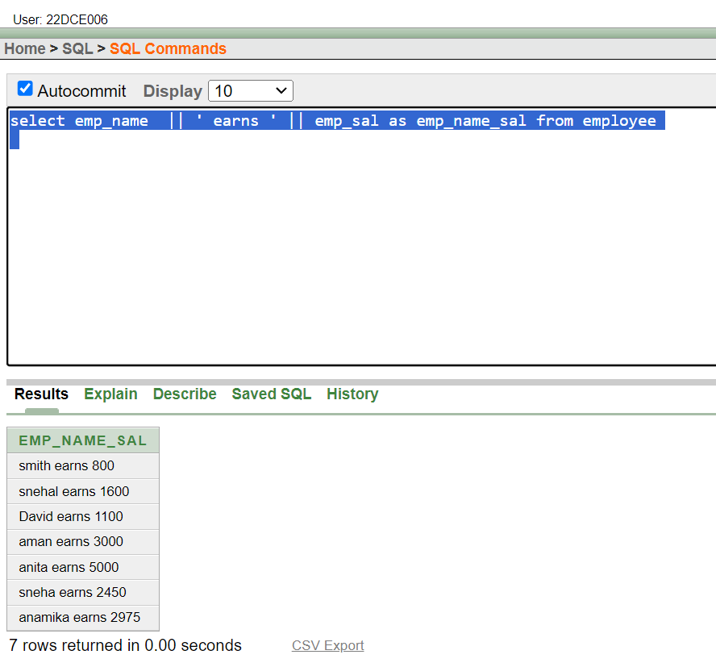

(6) Display the name, date, number of months employed and day of the week on which the employee has started. Order the results by the day of the week starting with Monday.

**Query: select emp_name,hiredate,round(months_between(sysdate,hiredate),0) as "MONTH_WORKED", to_char(hiredate,'DAY') AS "DAY_OF_WEEKS" from employee order by (hiredate-NEXT_DAY(hiredate,'monday'))**

**Output:**

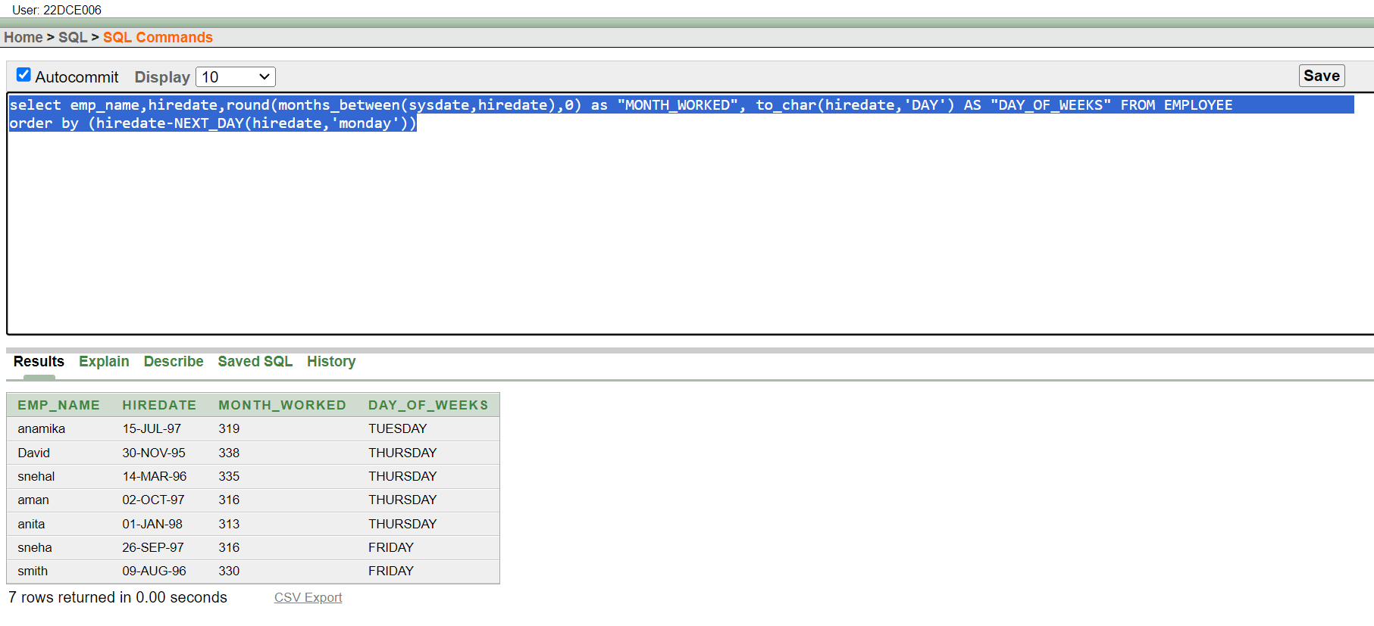

(7) Display the date of emp in a format that appears as Seventh of June 1994 12:00:00 AM.

**Query: select to_char(a_date,'DDth Month yyyy HH:MM:SS') from deposit**

**Output:**

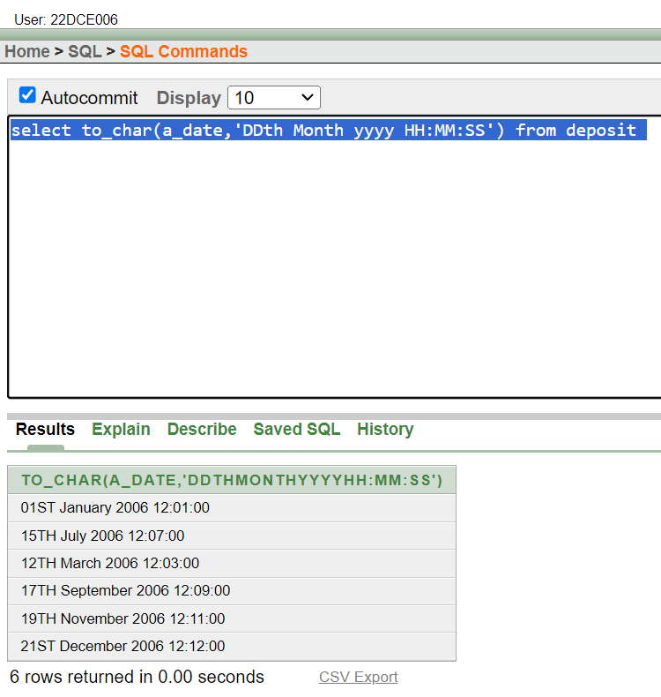

(8) Write a query to calculate the annual compensation of all employees (sal +comm.).

**Query: select sum(emp_sal +emp_comm) from employee**

**Output:**

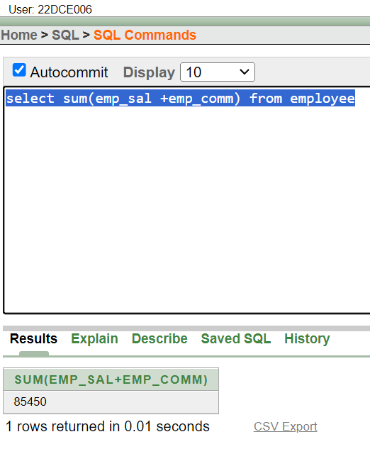

**Conclusion:** From this practical I learned about different SQL commands that can be used for data manipulation and single row SQL functions which are useful to getting one output per row.

**Staff Signature:**

**Grade:**

**Remarks by the Staff:**

**Practical 5**

**Aim: Displaying data from Multiple Tables (join)**

(1) Give details of customers ANIL.

**Query :** select *from deposit where cname='anil'

**Output:**

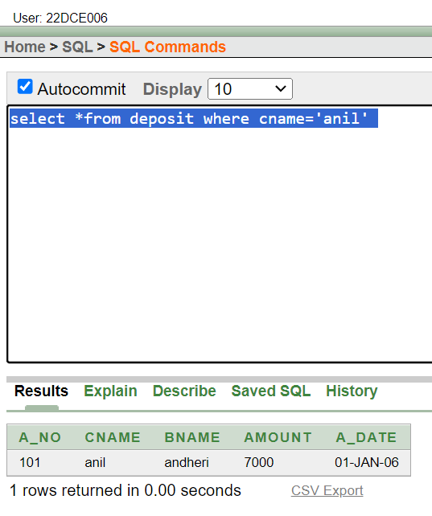

(2) Give name of customer who are borrowers and depositors and having living city nagpur

**Query :** select customer.cname from customer inner join borrow on borrow.cname=customer.cname inner join deposit on deposit.cname=customer.cname where city ='NAGPUR'

**Output:**

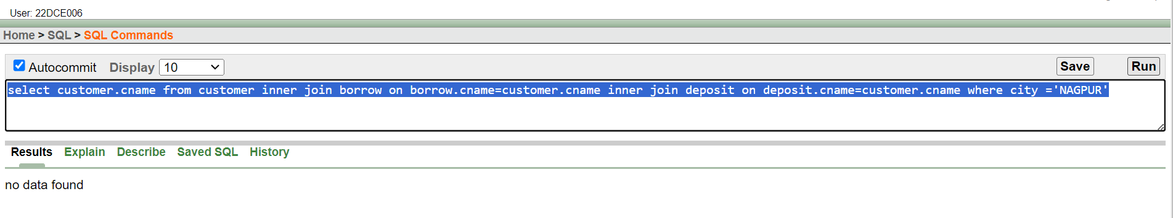

(3) Give city as their city name of customers having same living branch.

**Query :** select city as "city_name" from deposit natural join borrow natural join customer where bname=bname;

**Output:**

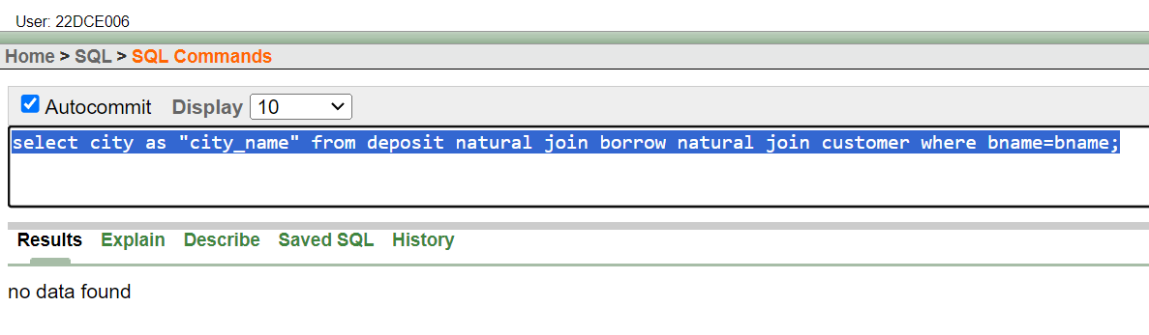

(4) Write a query to display the last name, department number, and department name for all employees.

**Query :** select l_name,dept_no,dept_name from employee

**Output:**

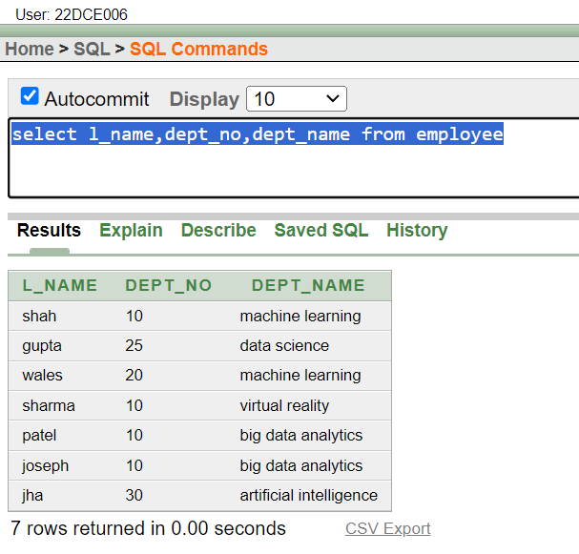

(5) Create a unique listing of all jobs that are in department 30. Include the location of the department in the output

**Query :** select job.job_id from job inner join employee on employee.job_id=job.job_id and dept_no=30

**Output:**

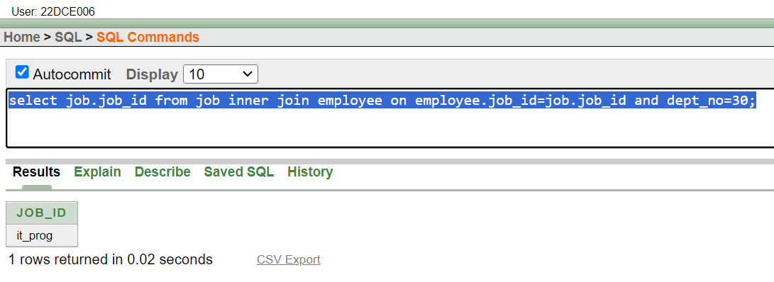

(6) Write a query to display the employee’s name, department number, and department name for all employees who work in NEW YORK.

**Query :** select emp_name,dept_no,dept_name from employee where location='new york'

**Output:**

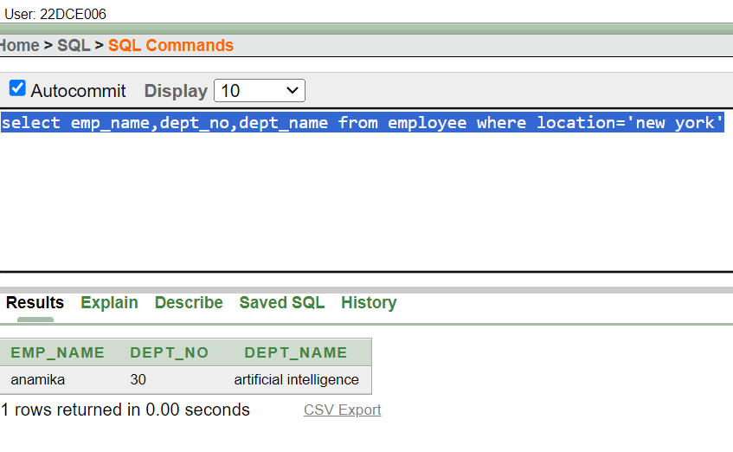

(7) Display the employee’s last name and employee number along with their manager’s last name and manager number. Label the columns Employee, Emp#, Manager, and Mgr#, respectively.

**Query :** select employee.l_name as EMP#,employee.emp_no,employee.job_id as job_info,job.job_title AS JOB# from employee left outer join job on employee.job_id=job.job_id;

**Output:**

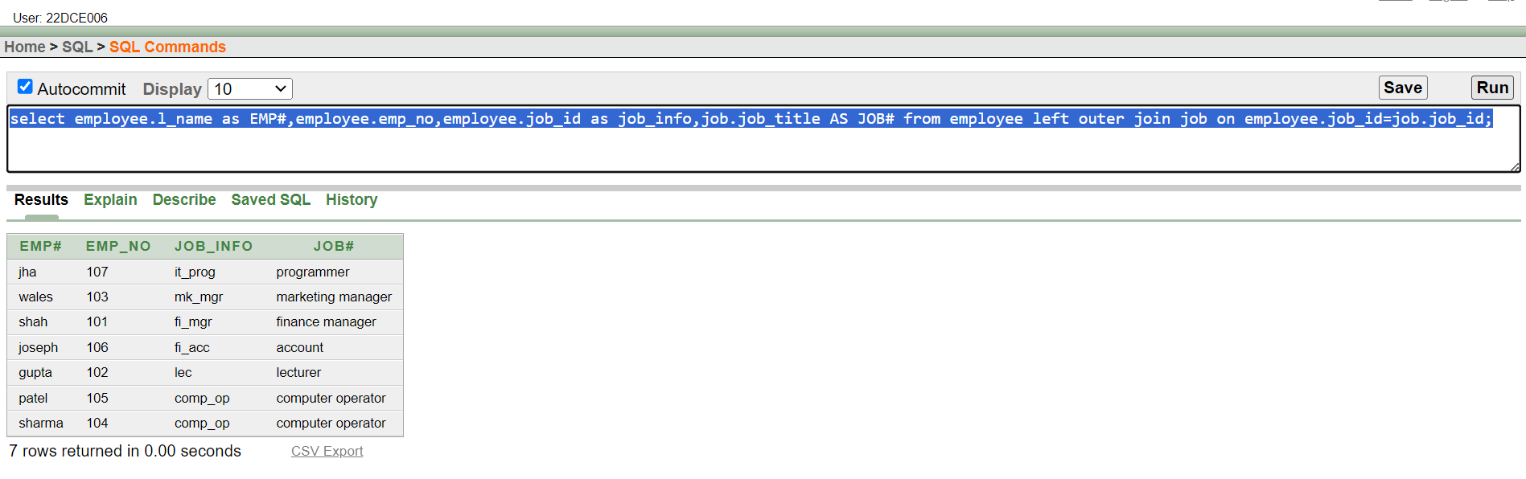

(8) Create a query to display the name and hire date of any employee hired after employee “smith”.

**Query :** select emp_name||' '|| hiredate from employee where hiredate>(select hiredate from employee where emp_name='smith')

**Output:**

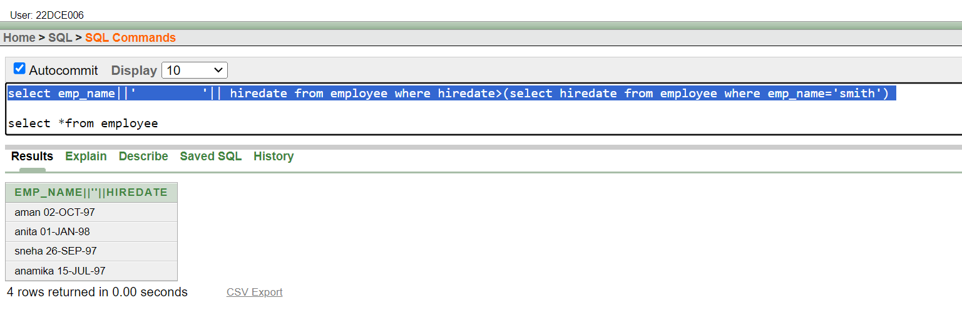

**Conclusion:** From this practical I learned about different SQL commands that can be used for data manipulation and join SQL functions which are useful for getting output by combining multiple tables.

**Staff Signature:**

**Grade:**

**Remarks by the Staff:**

**Practical 6**

**Aim: To apply the concept of Aggregating Data using Group functions.**

(1)List total deposit of customer having account date after 1-jan-96.

**Query:** select sum(amount) from deposit where a_date>'01-jan-96'

**Output:**

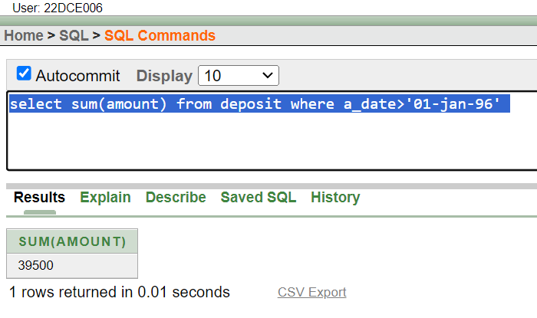

(2) List total deposit of customers living in city Nagpur.

**Query:** select sum(amount) as "SUM" from deposit where bname='nagpur'

**Output:**

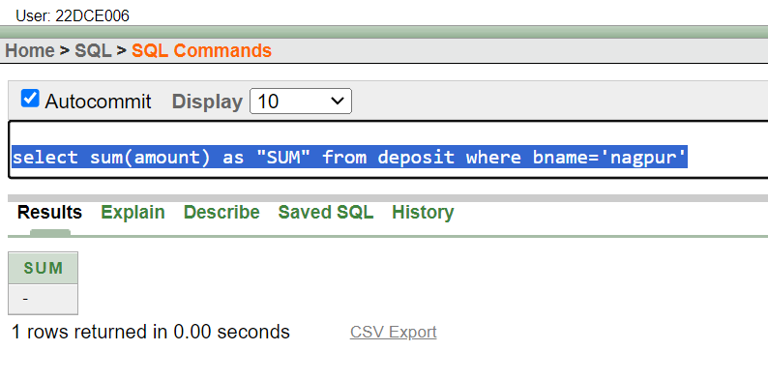

(3) List maximum deposit of customers living in bombay.

**Query:**select max(amount) as "MAX" from deposit where bname='bombay'

**Output:**

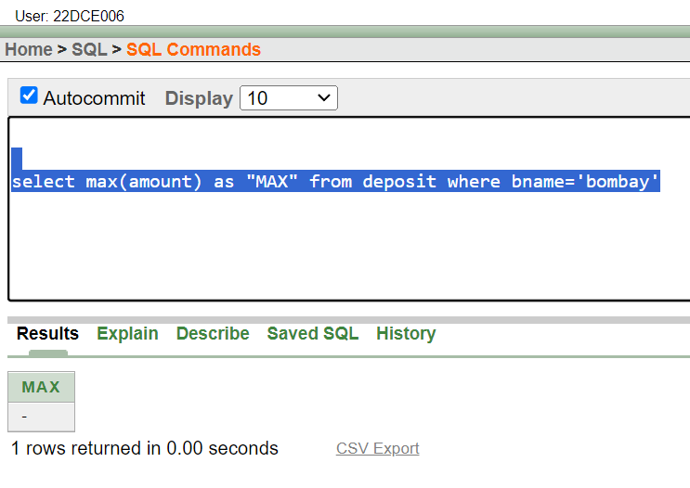

(4) Display the highest, lowest, sum, and average salary of all employees. Label the columns Maximum, Minimum, Sum, and Average, respectively. Round your results to the nearest whole number.

**Query:** select round(max(emp_sal)) as "Maximum Salary" , round(min(emp_sal)) as"Minimum Salary" , round(sum(emp_sal)) as"Total Salary" , round(avg(emp_sal)) as"Average Salary" from employee

**Output:** 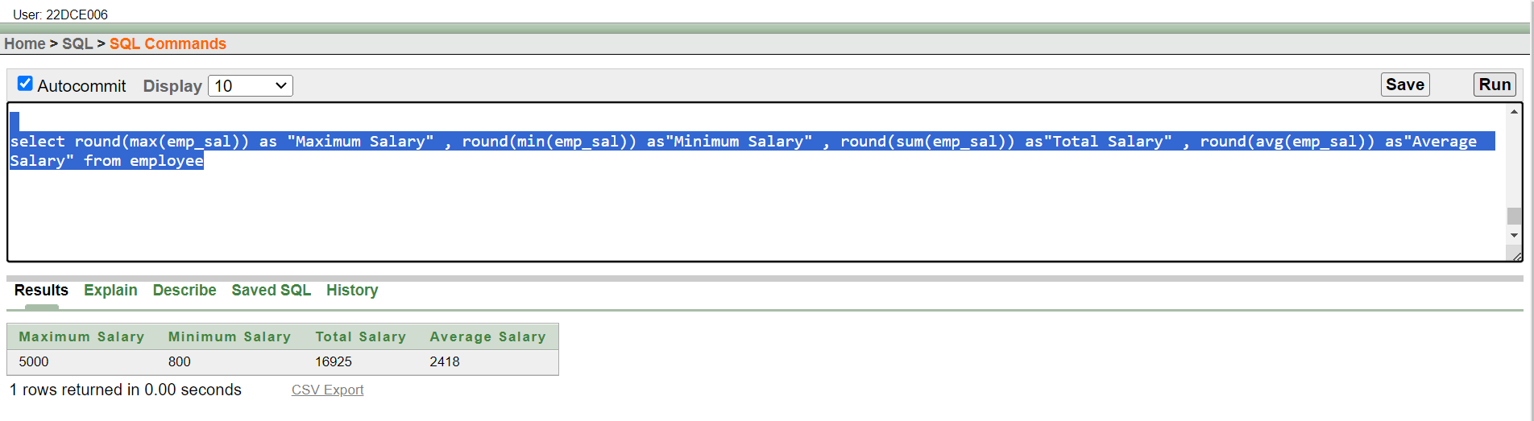

(5) Write a query that displays the difference between the highest and lowest salaries. Label the column DIFFERENCE.

**Query:** select round(max_sal) as "Highest Salary" , round(min_sal) as"Lowest Salary" , round((max_sal)-(min_sal))as "Difference" from job

**Output:**

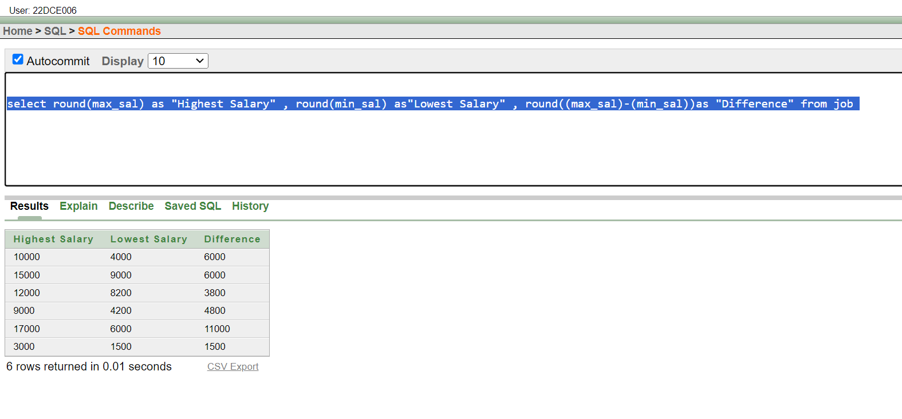

(6) Create a query that will display the total number of employees and, of that total, the number of employees hired in 1995, 1996, 1997, and 1998

**Query:** select count(emp_name) as "Count" from employee where to_char(hiredate,'yy') in('95','96','97','98')

**Output:**

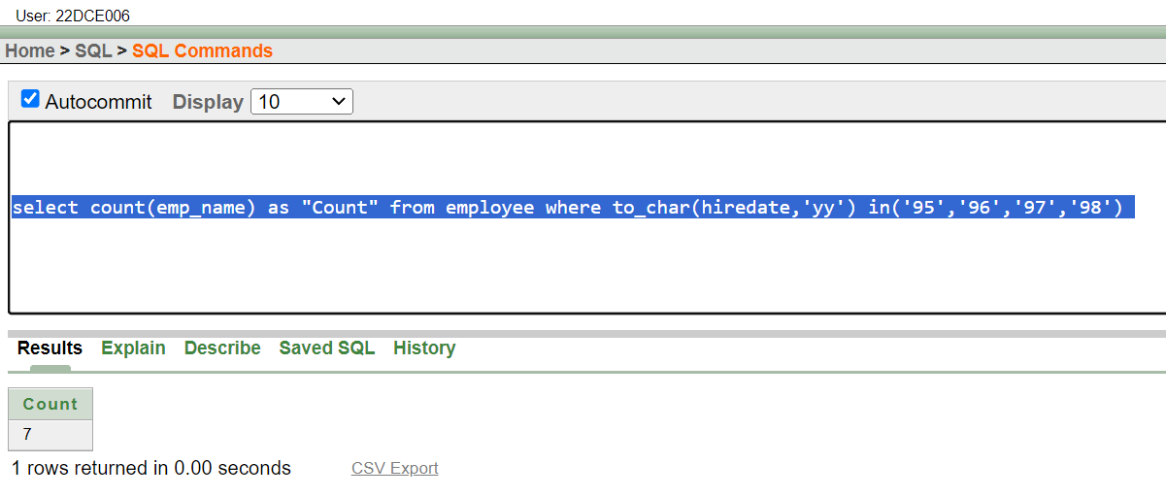

(7) Find the average salaries for each department without displaying the respective department numbers.

**Query:** select dept_no,ROUND(AVG(emp_sal)) from employee GROUP BY dept_no

**Output:**

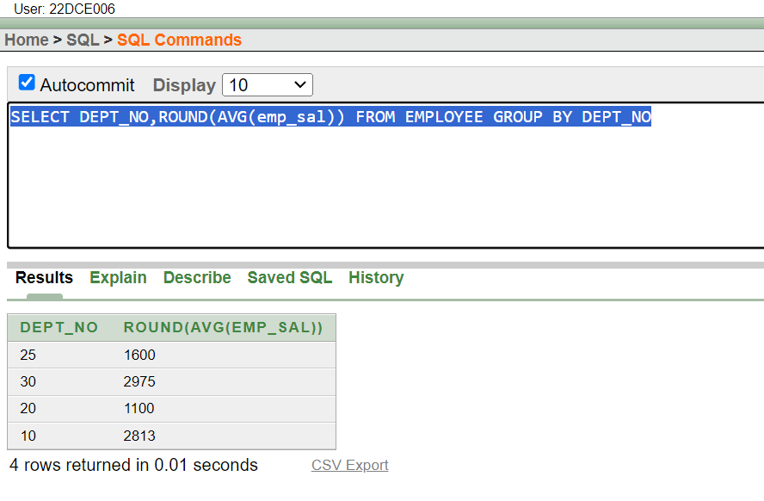

(8) Write a query to display the total salary being paid to each job title, within each department.

**Query:** select dept_name, SUM(emp_sal) from employee GROUP BY dept_name

**Output:** 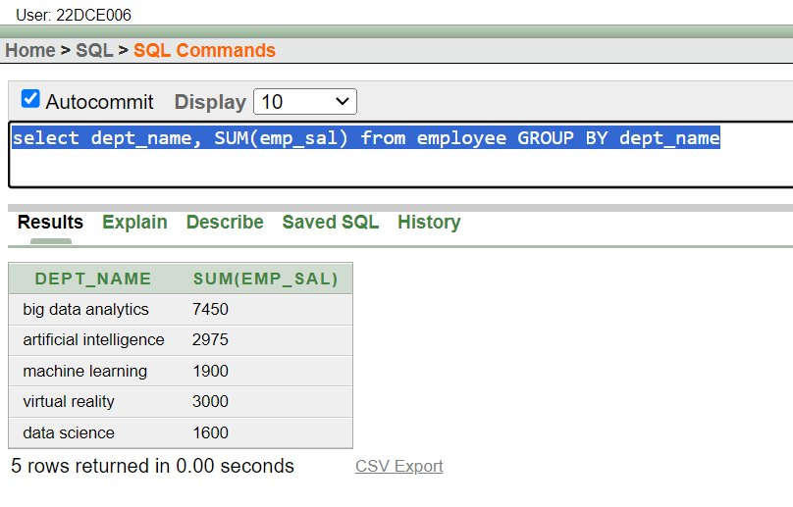

(9) Find the average salaries > 2000 for each department without displaying the respective department numbers.

**Query:** select ROUND(AVG(emp_sal)) from employee GROUP BY dept_no HAVING AVG(EMP_SAL)>2000

**Output:** 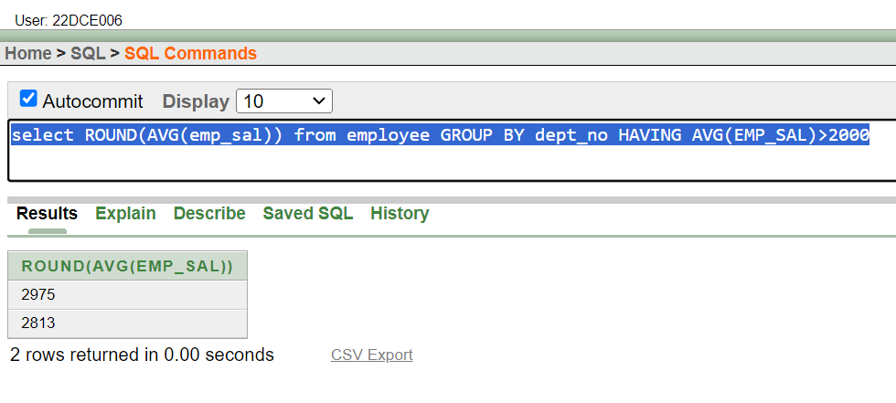

(10) Display the job and total salary for each job with a total salary amount exceeding 3000 and sorts the list by the total salary.

**Query:** select job_id,SUM(emp_sal+3000)"EXTENDED SALARY " from employee GROUP BY job_id order by SUM(emp_sal+3000)

**Output:** 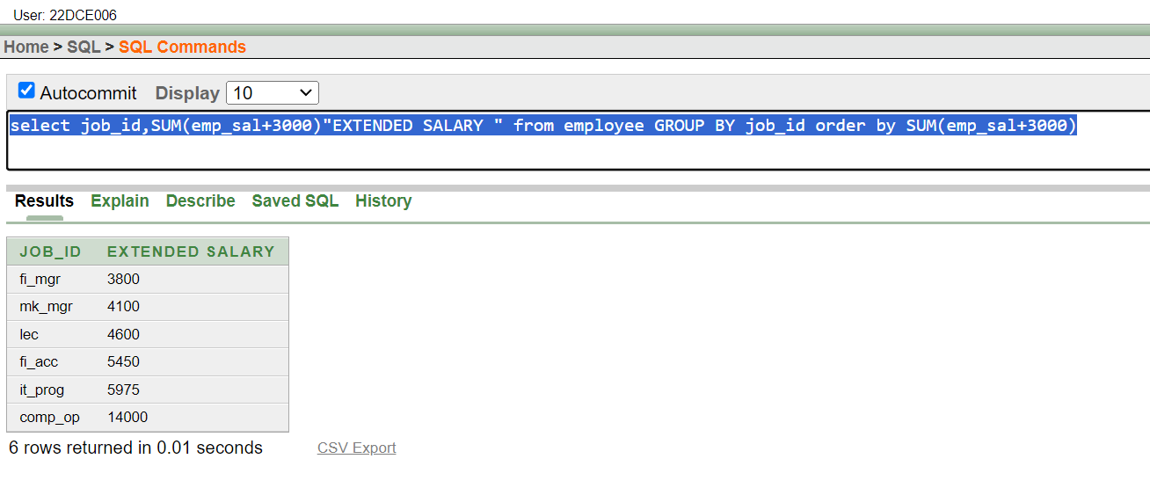

(11) List the branches having sum of deposit more than 5000 and located in city bombay.

**Query:** select bname from deposit group by bname having sum(amount)>5000

**Output:**

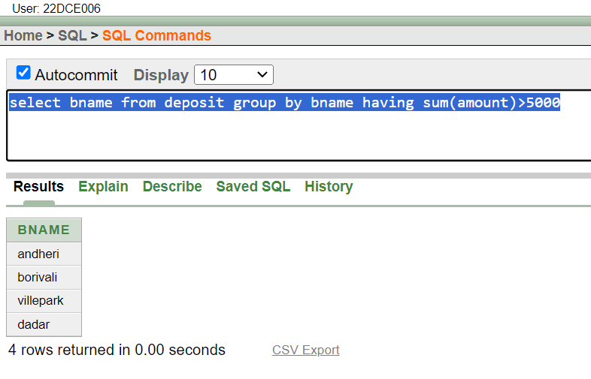

**Conclusion:** From this practical I learned about different aggregate functions and other SQL group functions.

**Staff Signature:**

**Grade:**

**Remarks by the Staff:**

**Practical 7**

**Aim: To solve queries using the concept of sub query.**

(1) Write a query to display the last name and hire date of any employee in the same department as smith. Exclude smith

**Query:** select l_name,hiredate from employee where dept_name=(select dept_name from employee where emp_name='smith') and emp_name!='smith'

**Output:**

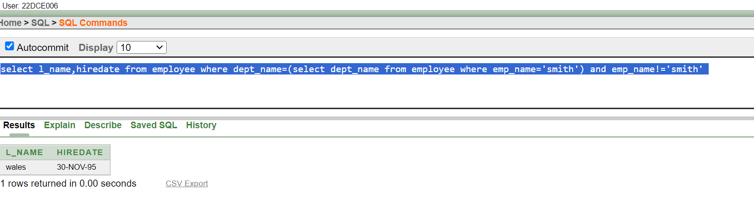

(2) Give name of customers who are depositors having same branch city of mr. sunil.

**Query:** select cname from deposit where bname=(select bname from deposit where cname='sunil')

**Output:**

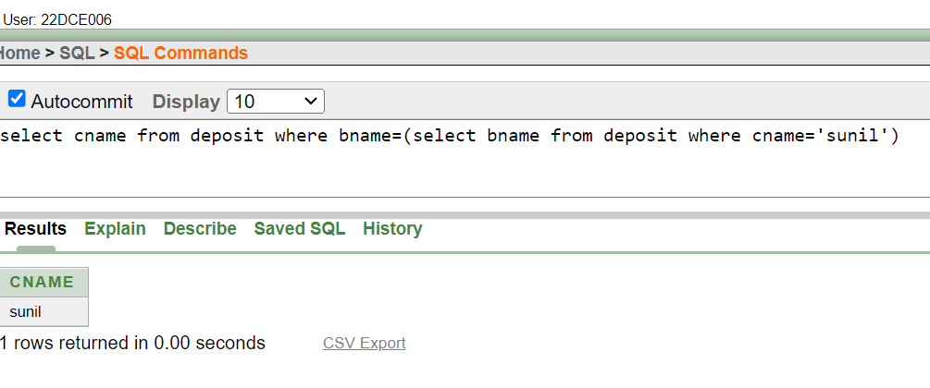

(3) Give deposit details and loan details of customer in same city where pramod is living.

**Query:** select *from deposit,borrow where bname=(select bname from deposit where cname='pramod')

**Output:**

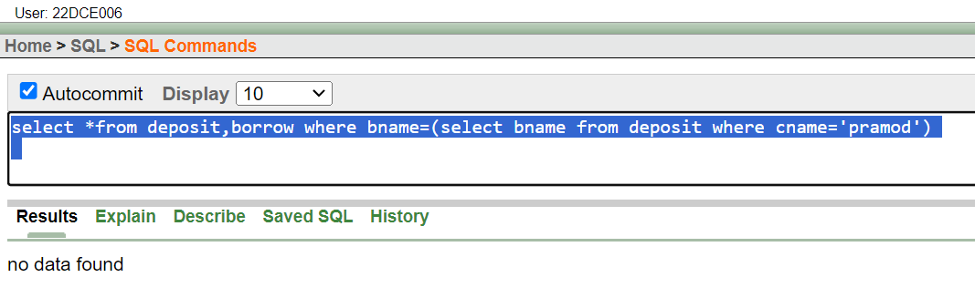

(4) Create a query to display the employee numbers and last names of all employees who earn more than the average salary. Sort the results in ascending order of salary.

**Query:** select emp_no,l_name from employee where emp_sal>(select avg(emp_sal) from employee) order by emp_sal asc

**Output:** 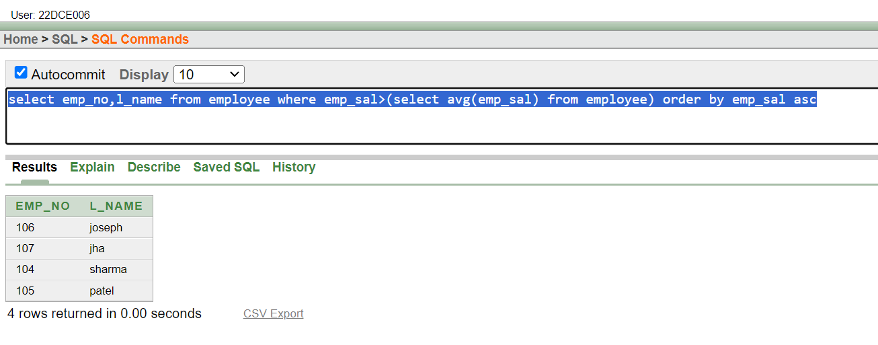

(5) Give names of depositors having same living city as mr. anil and having deposit amount greater than 2000

**Query:** select cname from deposit where bname=(select bname from deposit where cname='anil' and amount>2000);

**Output:**

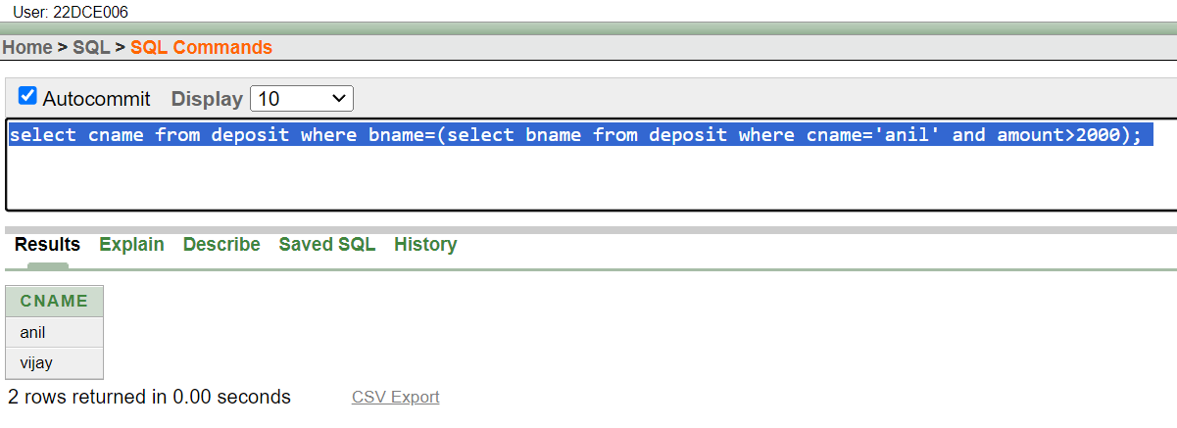

(6) Display the last name and salary of every employee who reports to patel.

**Query:** select l_name , emp_sal from employee where manager_id=105;

**Output:**

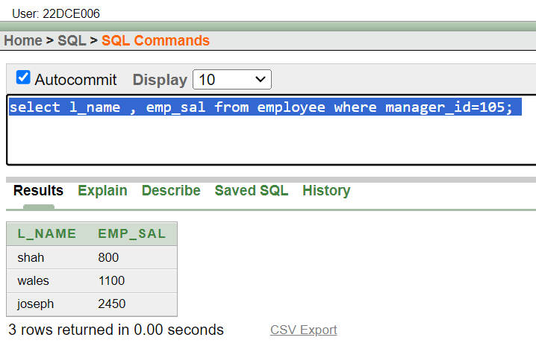

(7) Display the department number, name, and job for every employee in the accounting department.

**Query:** select dept_no,emp_name,job_id from employee where job_id=(select job_id from job where upper(job_title)='ACCOUNT')

**Output:**

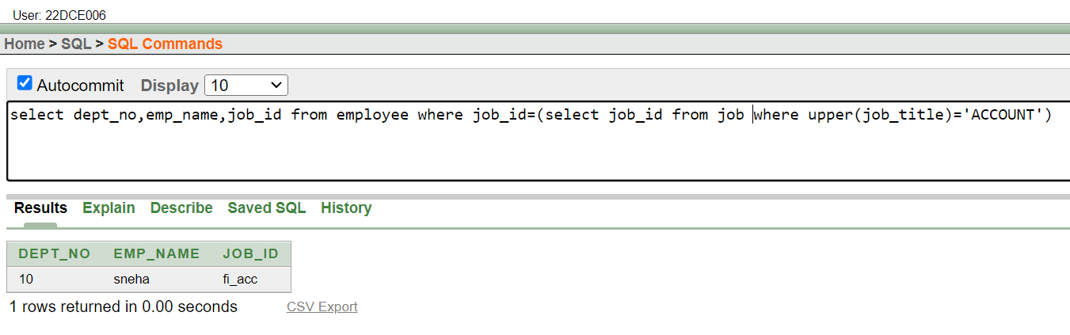

(8) List the name of branch having highest number of depositors.

**Query:** select bname from deposit group by bname having count(bname)>=(select max(count(bname)) from deposit group by bname)

**Output:**

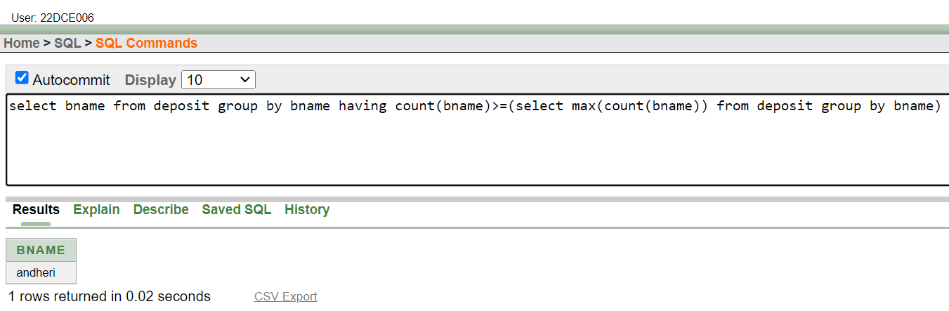

(9) Give the name of cities where in which the maximum numbers of branches are located.

**Query:** select bname from deposit group by bname having count(bname)>=(select max(count(bname)) from deposit group by bname)

**Output:**

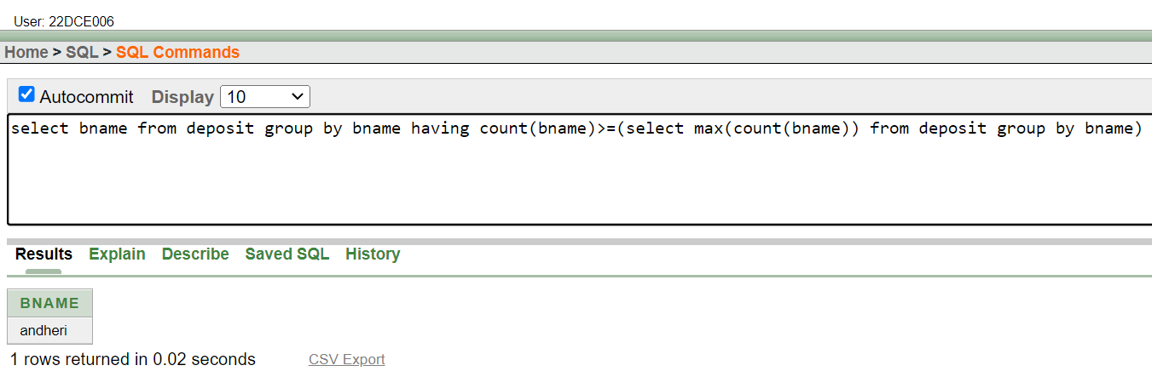

(10) Give name of customers living in same city where maximum depositors are located.

**Query:** select cname from customers where city=(select bname from deposit group by bname having count(bname)>=select(max(count(bname)) from deposit group by bname))

**Output:**

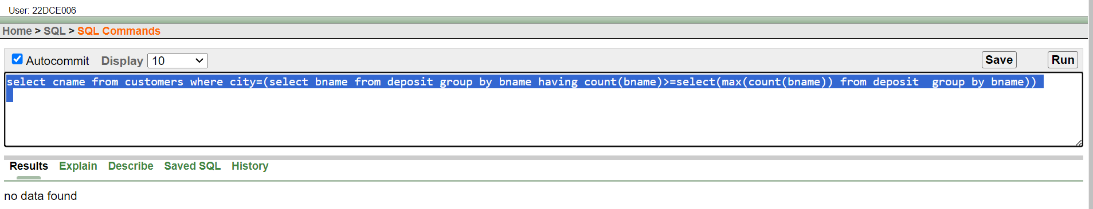

**Conclusion:** From this practical I learned about different aggregate functions , application of sub-queries and other SQL group functions.

**Staff Signature:**

**Grade:**

**Remarks by the Staff:**

**Practical 8**

**Aim: Manipulating Data**

**(1) Give 10% interest to all depositors.**

Query: update deposit set amount=(amount)+(amount*0.1)

Output:

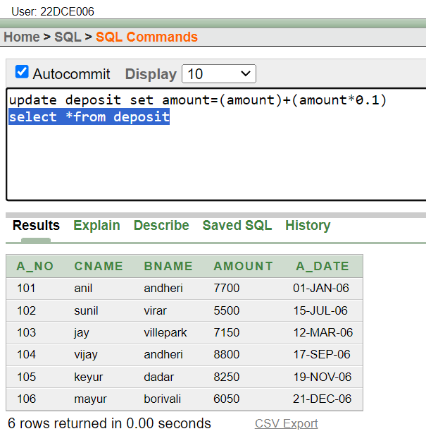

**(2) Give 10% interest to all depositors having branch vrce**

Query: update deposit set amount=(amount)+(amount*0.1) where bname='vrce'

Output:

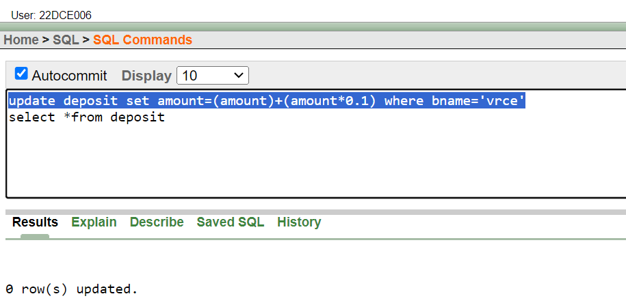

**(3) Give 10% interest to all depositors living in nagpur and having branch city bombay.**

Query: update deposit set amount=(amount)+(amount*0.1) where bname='nagpur' or bname='bombay'

Output:

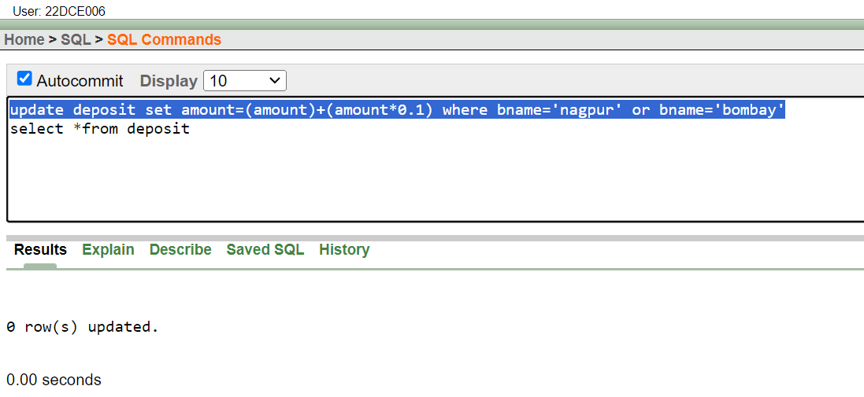

**(4) Write a query which changes the department number of all employees with empno 7788’s job to employee 7844’current department number.**

Query: update employee set emp_no=7844 where emp_no=7788

Output:

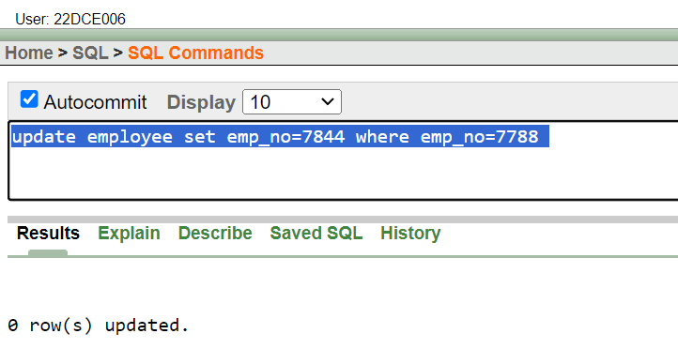

**(5) Transfer 10 Rs from account of anil to sunil if both are having same branch.**

Query: update deposit set amount=amount+10 where cname='sunil' and bname in (select bname from deposit where cname='anil')

Output:

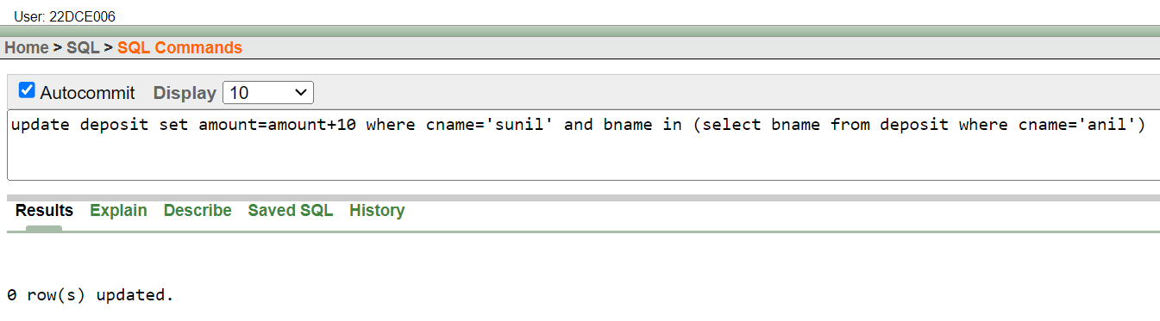

**(6) Give 100 Rs more to all depositors if they are maximum depositors in their respective branch.**

Query: UPDATE DEPOSIT SET AMOUNT=AMOUNT+100 WHERE CNAME IN(SELECT CNAME FROM DEPOSIT WHERE AMOUNT = ANY(SELECT MAX(AMOUNT) FROM DEPOSIT GROUP BY BNAME))

Output:

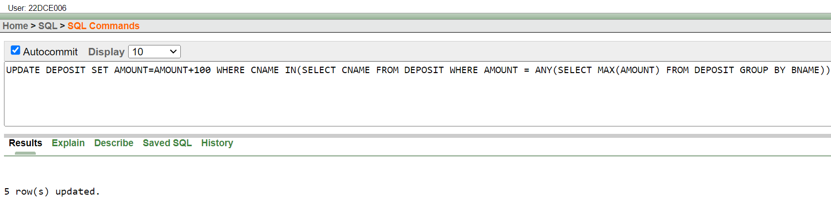

**(7) Delete depositors of branches having number of customers between 1 to 3.**

Query: DELETE FROM DEPOSIT WHERE BNAME IN(SELECT BNAME FROM DEPOSIT GROUP BY BNAME HAVING COUNT(BNAME)>1 AND COUNT(BNAME)<3)

Output:

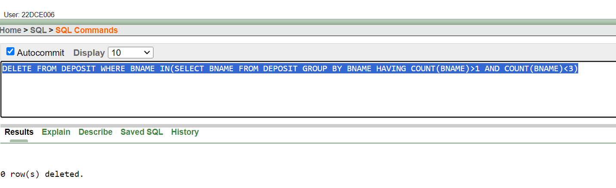

**(8) Delete deposit of vijay.**

Query: delete from deposit where cname=’vijay’

Output:

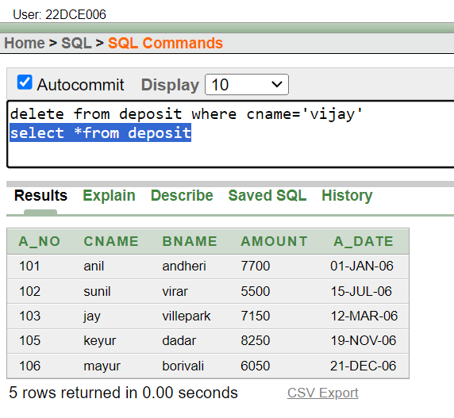

**(9) Delete borrower of branches having average loan less than 1000.**

Query: delete from borrow where amount<1000

Output:

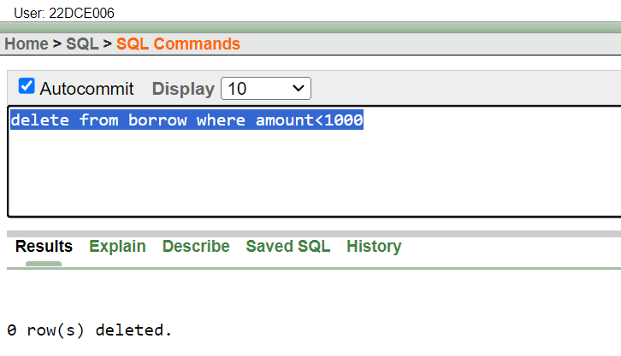

**Conclusion:** From this practical I learned about different functions used for data manipulation and other important queries.

**Staff Signature:**

**Grade:**

**Remarks by the Staff:**

**Practical 9**

**Aim: Add and Remove constraint**

**(1) Add primary key constraint on job_id in job table.**

Query: alter table job add constraint pk_id primary key(job_id)

Output:

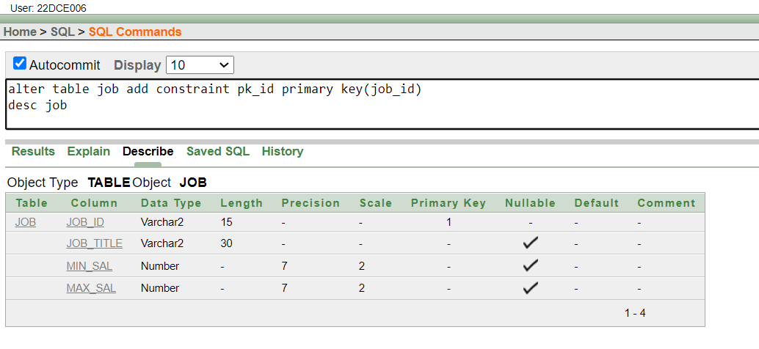

**(2) Add foreign key constraint on employee table referencing job table.**

Query: alter table employee add constraint fk_emp foreign key(job_id) references job(job_id)

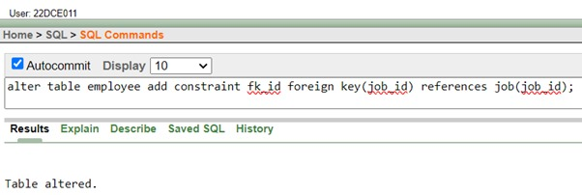Output:

**(3) Add composite primary key on lock table (lock table does not exist, while creating table add composite key)**

Query: create table lock1(s_id number(10),fname varchar2(10) , lname varchar2(10) , primary key(s_id,fname))

Output:

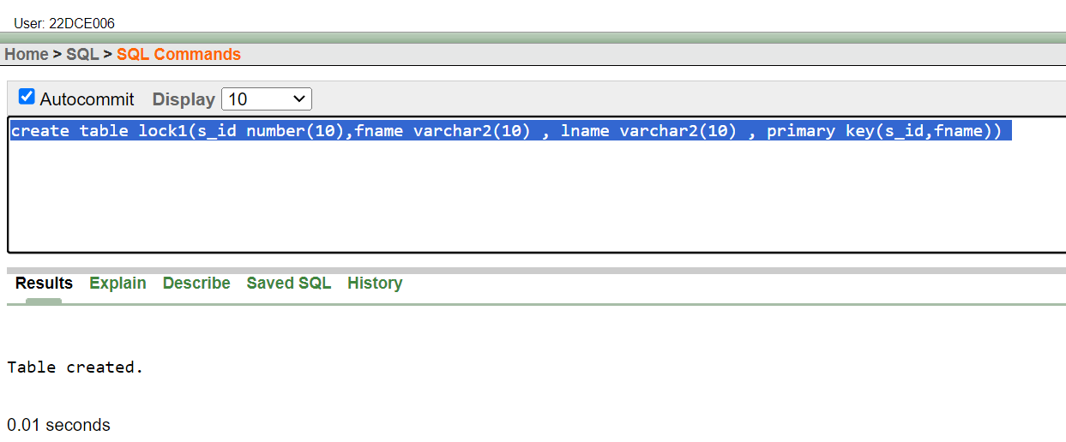

**(4) Remove primary key constraint on job_id**

Query: alter table employee drop constraint fk_id

Output:

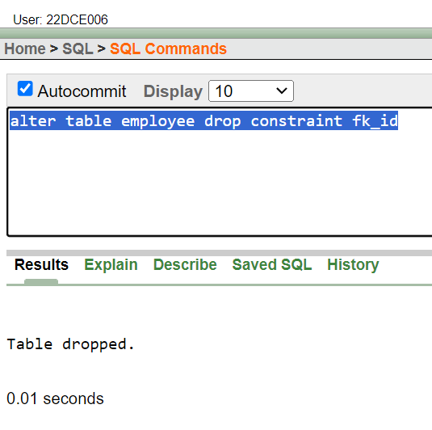

**(5) Remove foreign key constraint on employee table**

Query: alter table job drop constraint pk_id

Output:

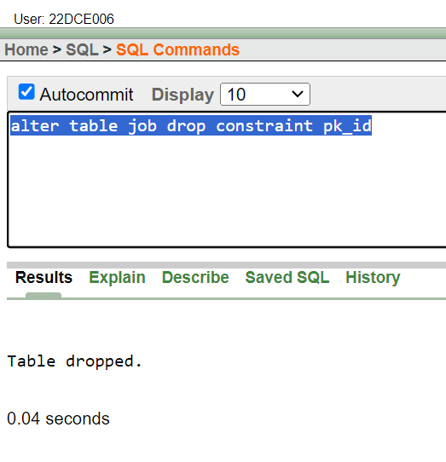

**Conclusion:** From this practical I learned about adding and removing primary key and foreign keys.

**Staff Signature:**

**Grade:**

**Remarks by the Staff:**

**Practical 10**

**Aim: To perform basic PL/SQL blocks**

1**. Write a PL-SQL block for checking weather a given year is a Leap year or not.**

Query:

DECLARE

year NUMBER := 2004;

BEGIN

IF MOD(year, 4)=0

AND

MOD(year, 100)!=0

OR

MOD(year, 400)=0 THEN

dbms_output.Put_line(year || ' is a leap year ');

ELSE

dbms_output.Put_line(year || ' is not a leap year.');

END IF;

END;

Output:

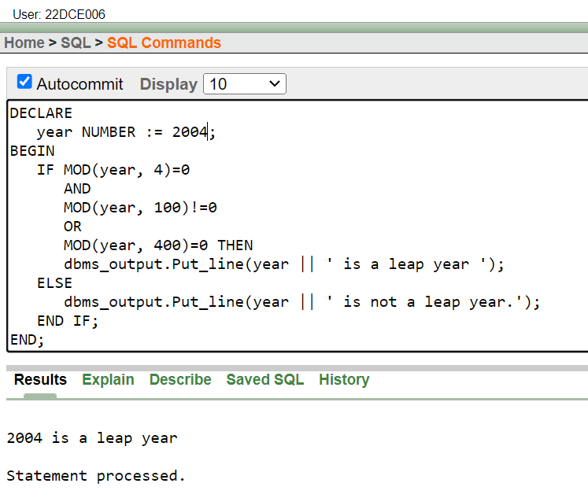

**2. Find out whether given string is palindrome or not using for a while and simple loop.**

**Using For Loop**

Query:

DECLARE

input_string VARCHAR2(100) := 'naman';

is_palindrome BOOLEAN := TRUE;

BEGIN

FOR i IN 1..LENGTH(input_string)

LOOP

IF SUBSTR(input_string, i, 1) != SUBSTR(input_string, LENGTH(input_string) - i + 1, 1) THEN

is_palindrome := FALSE;

EXIT;

END IF;

END LOOP;

IF is_palindrome THEN

DBMS_OUTPUT.PUT_LINE(input_string || ' - The given string is a palindrome.');

ELSE

DBMS_OUTPUT.PUT_LINE(input_string || ' - The given string is not a palindrome.');

END IF;

END;

Output:

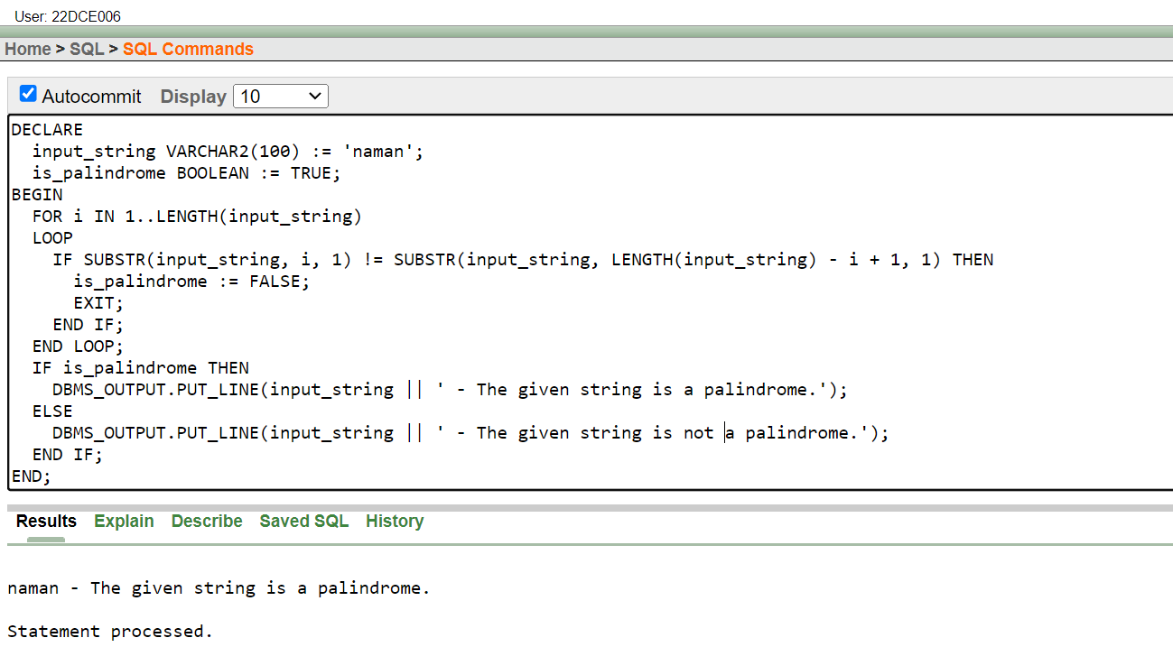

**Using While Loop**

Query:

DECLARE

input_string VARCHAR2(100) := 'naman';

is_palindrome BOOLEAN := TRUE;

i NUMBER := 1;

BEGIN

WHILE i <= LENGTH(input_string)

LOOP

IF SUBSTR(input_string, i, 1) != SUBSTR(input_string, LENGTH(input_string) - i + 1, 1) THEN

is_palindrome := FALSE;

EXIT;

END IF;

i := i + 1;

END LOOP;

IF is_palindrome THEN

DBMS_OUTPUT.PUT_LINE(input_string||' - The given string is a palindrome.');

ELSE

DBMS_OUTPUT.PUT_LINE(input_string||' - The given string is not a palindrome.');

END IF;

END;

Output:

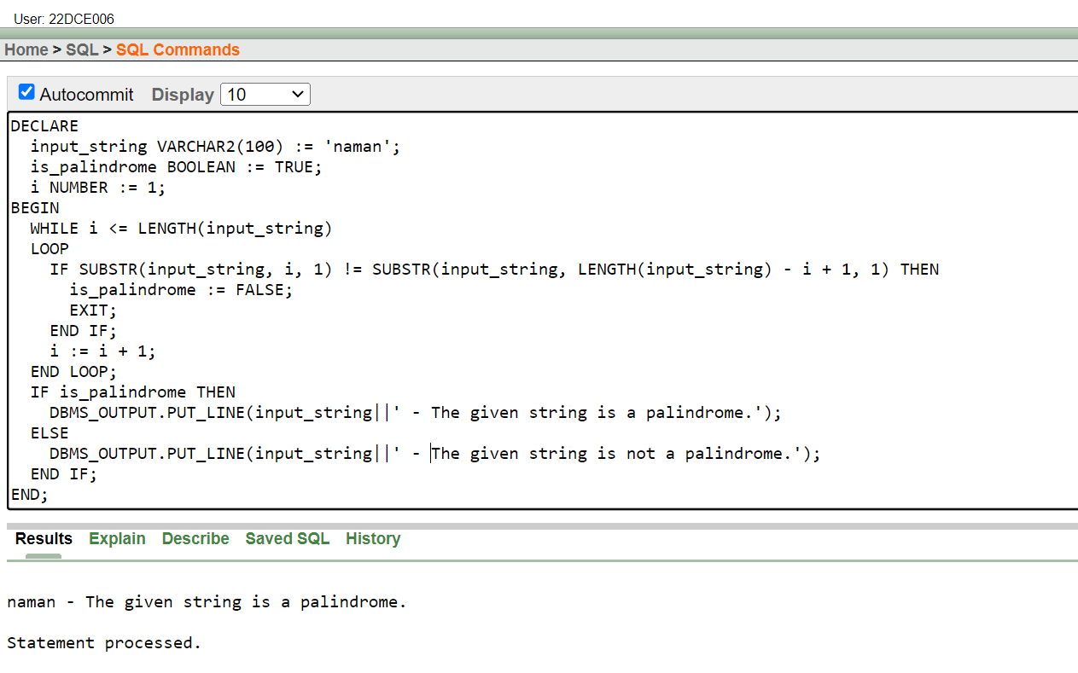

**Conclusion:** From this practical I learned about basic pl/sql functions and use of loops.

**Staff Signature:**

**Grade:**

**Remarks by the Staff:**

**Practical 11**

**Aim: To understand the concept of “select into” and “% type” attribute.**

Create an EMPLOYEES table that is a replica of the EMP table. Add a new column, STARS, of VARCHAR2 data type and length of 50 to the EMPLOYEES table for storing asterisk (*).

Create a PL/SQL block that rewards an employee by appending an asterisk in the STARS column for every Rs1000/- of the employee’s salary. For example, if the employee has a salary amount of Rs8000/-, the string of asterisks should contain eight asterisks. If the employee has a salary amount of Rs12500/-, the string of asterisks should contain 13 asterisks. Update the STARS column for the employee with the string of asterisks.

**i)**

**Query:** alter table employee add STARS varchar2(50);

**Output:**

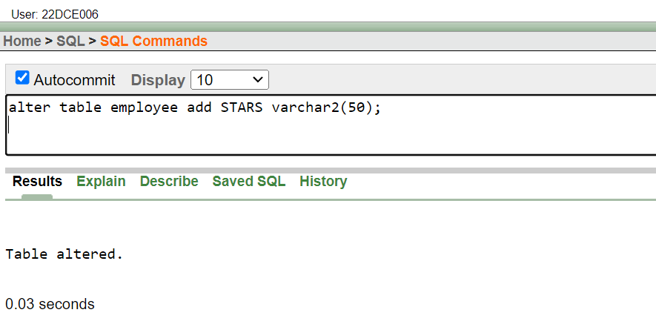

**ii)**

**Query:**

declare

star_sal number;

itr number;

no number := 101;

nofstars varchar2(20);

begin

while no < 108 loop

select emp_sal into star_sal from employee where emp_no = no;

itr := ceil(star_sal/1000);

for i in 1..itr loop

nofstars := nofstars || '*';http://127.0.0.1:8080/apex/f?p=4500:1003:3486766455597079::NO:1003::#

end loop;

update employee set stars=nofstars where emp_no = no;

nofstars := '';

no := no +1;

end loop;

end;

select *from employee

**Output:**

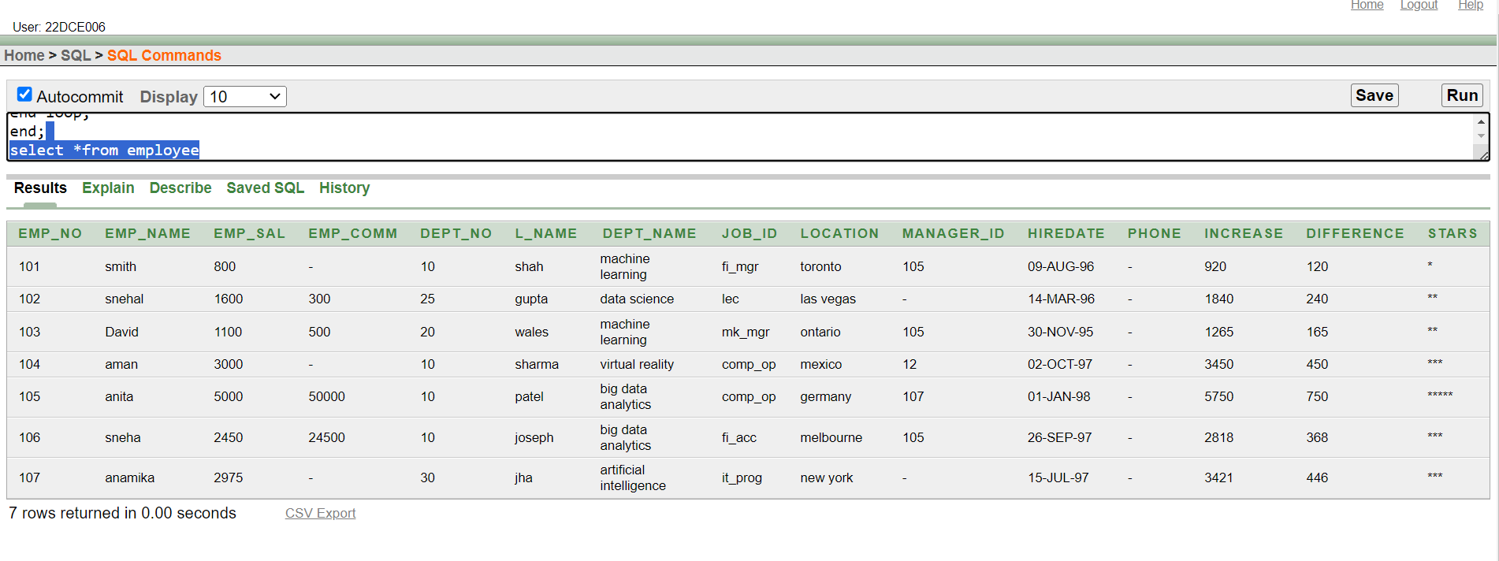

**Conclusion:** From this practical I learned about the concept of “select into “query ,”%type” attribute and its implementation.

**Staff Signature:**

**Grade:**

**Remarks by the Staff:**

**Practical 12**

**Aim: To perform the concept of cursor**

(a) Display all the information of EMP table using %ROWTYPE.

(b) Create a PL/SQL block that does the following:

In a PL/SQL block, retrieve the name, salary, and MANAGER ID of the employees working in the particular department. Take Department Id from user.

If the salary of the employee is less than 1000 and if the manager ID is either 7902 or 7839, display the message <<last name>> Due for a raise. Otherwise, display the message <<last_name>> Not due for a raise.

(c) In a loop, use a cursor to retrieve the department number and the department name from the DEPT table for those departments whose DEPT_ID is less than 100. Pass the department number to another cursor to retrieve from the EMP table the details of employee name, job, hire date, and salary of those employees whose EMP_NO is less than 7566 and who work in that department

**i)**

**Query:**

declare

cursor c1 is select * from employee;

v1 c1%rowtype;

begin

open c1;

loop

fetch c1 into v1;

exit when c1%notfound;

dbms_output.put_line(v1.emp_no || ' ' || v1.emp_name || ' ' ||v1.emp_sal || ' ' ||v1.emp_comm || ' ' ||v1.dept_no ||' ' || v1.l_name || ' ' ||v1.dept_name || ' ' ||v1.job_id || ' ' ||v1.location || ' ' ||v1.manager_id || ' ' ||v1.hiredate);

end loop;

close c1;

end;

**Output:**

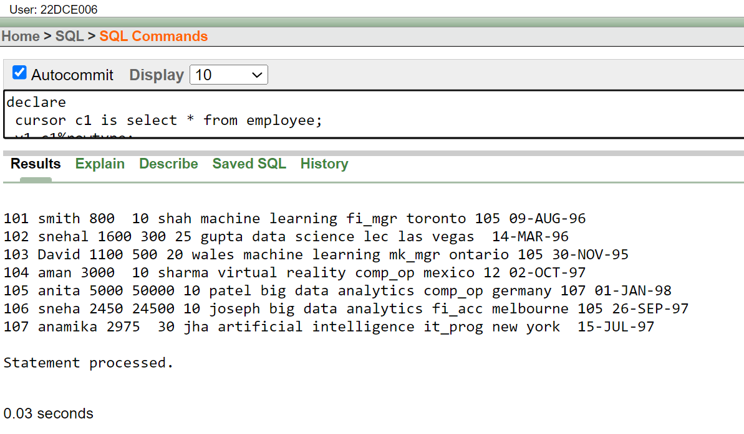

**ii)**

**Query:**

declare

D_no number:=:ENter_no;

cursor c2 is select emp_name,emp_sal,manager_id from employee where DEPT_NO=D_no;

v2 c2%rowtype;

begin

open c2;

loop

fetch c2 into v2;

if v2.emp_sal<1000 and (v2.manager_id = 7902 or v2.manager_id = 7839) then

dbms_output.put_line(v2.emp_name|| ' It is for raise.');

else

dbms_output.put_line(v2.emp_name|| ' It is not for raise.');

end if;

exit when c2%notfound;

end loop;

close c2;

end;

**Output:**

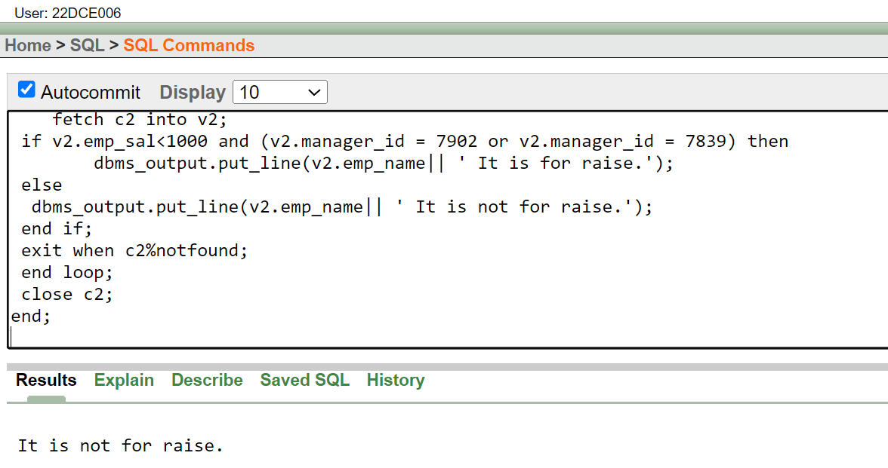

**iii)**

**Query-Output:**

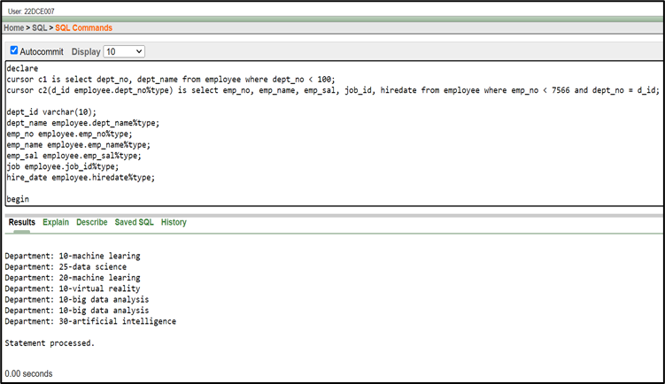

**Conclusion:** By performing this practical, I got to learn about concept of %rowtype and how to create cursor and use it to fetch the original table information using the cursor in PL-SQL Block.

**Staff Signature:**

**Grade:**

**Remarks by the Staff:**

**Practical 13**

**Aim: To solve queries using the concept of View.**

**(1) Write a query to create a view for those employees belongs to the location New York.**

**(2) Write a query to create a view for all employee with columns emp_id, emp_name, and job_id.**

**(3) Write a query to find the salesmen of the location New York who having salary more than 3000.**

**(4) Write a query to create a view to getting a count of how many employees we have at each department.**

**i)**

**Query:**

create view v1 as select * from employee where LOCATION='new york';

select from *v1

**Output:**

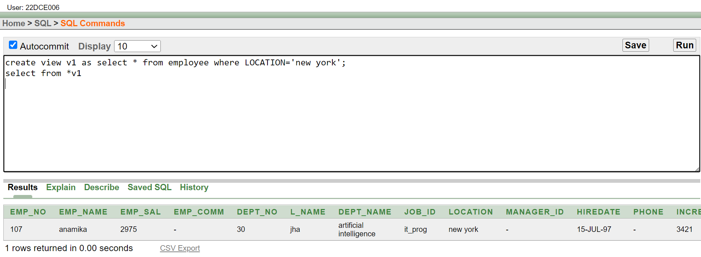

**ii)**

**Query:**

create view v2 as select emp_no,emp_name,job_id from employee

select from *v2

**Output:**

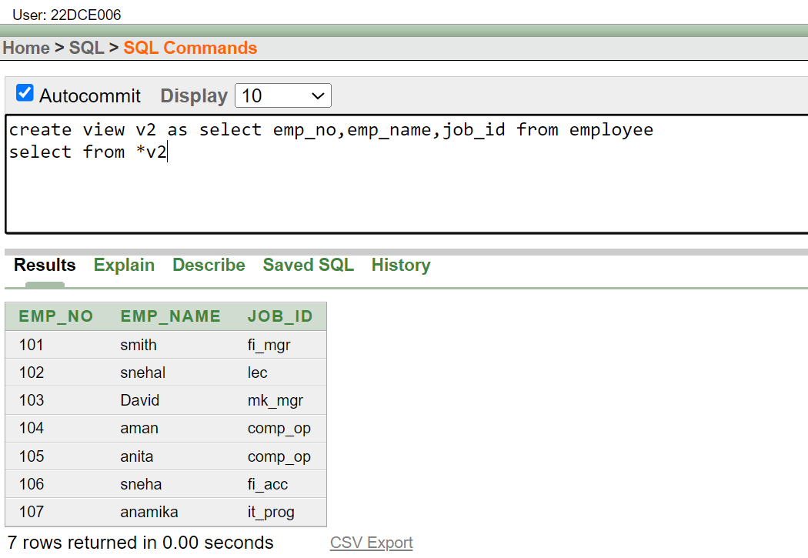

**iii)**

**Query:**

create view v3 as select emp_name from employee where location='new york' and emp_sal>3000;

select from *v3;

**Output:**

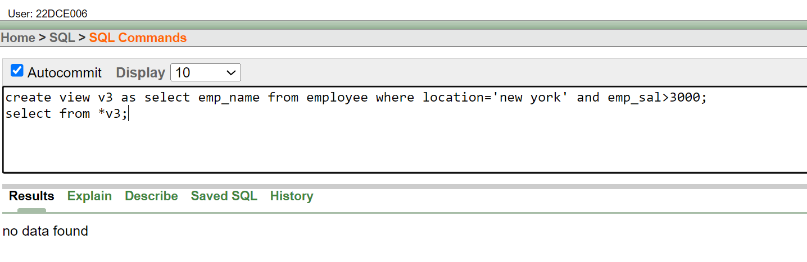

**iv)**

**Query:**

create view v4 as select dept_name,count(dept_name) as count from employee group by dept_name;

select from *v4;

**Output:**

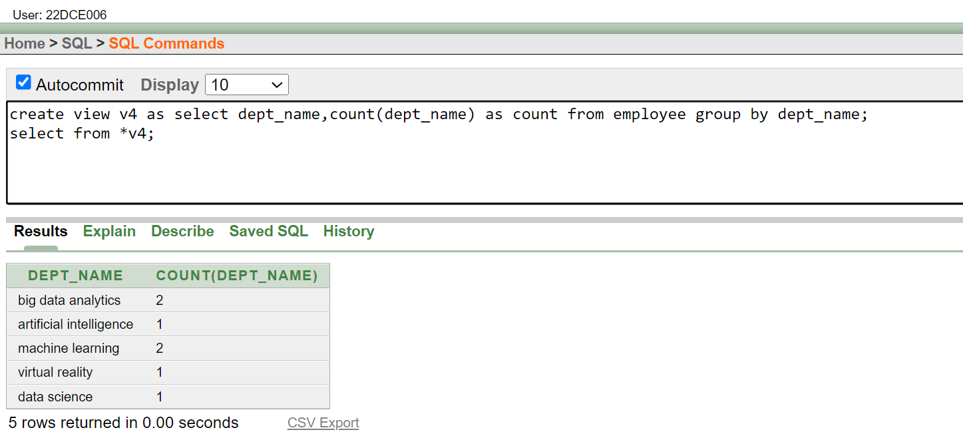

**Conclusion:** By performing this practical, I got to learn about the concepts of view in SQL. Also, got to understand about its use and how to create it.

**Staff Signature:**

**Grade:**

**Remarks by the Staff:**

**Practical 14**

**Aim: To perform the concept of function and procedure**

To update the salary of employee specified by empid. If record exist then update the salary otherwise display appropriate message. Write a function as well as procedure for updating salary.

**Query:**

create or replace function update_sal(new_sal in number)

return number

is new_s number;

begin

new_s:= new_sal;

new_s:=new_s+(new_s*0.1);

return new_s;

end;

declare

id number:= :Enter_emp_id;

a number;

b number;

begin

select emp_sal into a from employee where emp_no=id;

b:=update_sal(a);

if b=a then

dbms_output.put_line('Salary not updated');

else

dbms_output.put_line('Salary updated'||b||'with emp_id'||id);

end if;

end;

**Output:**

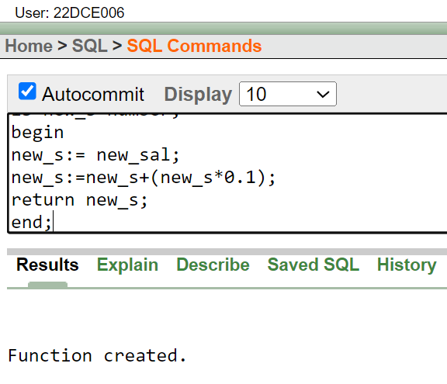

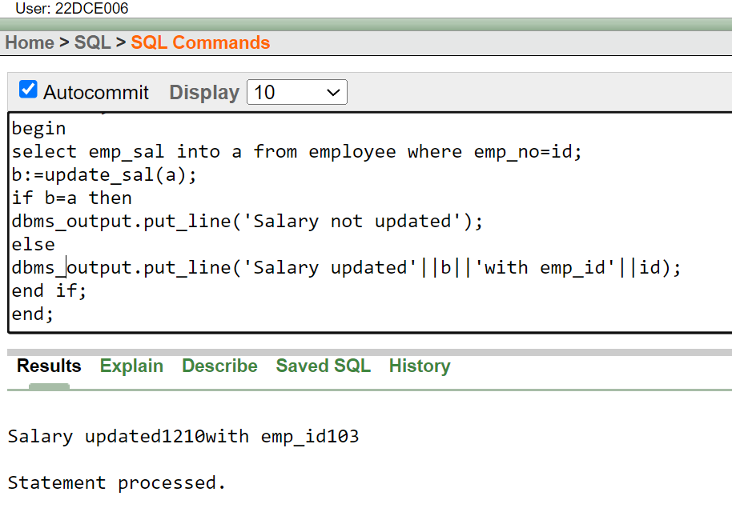

**Conclusion:** From performing this practical, I got to learn about use of function and procedure.

**Staff Signature:**

**Grade:**

**Remarks by the Staff:**

**Practical 15**

**Aim: To perform the concept of exception handler**

Write a PL/SQL block that will accept the employee code, amount and operation. Based on specified operation amount is added or deducted from salary of said employee. Use user defined exception handler for handling the exception.

**Query:**

declare

var1 number;

my_exception exception;

begin

select emp_sal into var1 from employee where emp_no=103;

if var1>2000 then

var1:=var1+3000;

else

raise my_exception;

end if;

exception

when my_exception then

dbms_output.put_line('Here Exception has occured!!!!');

end;

**Output:**

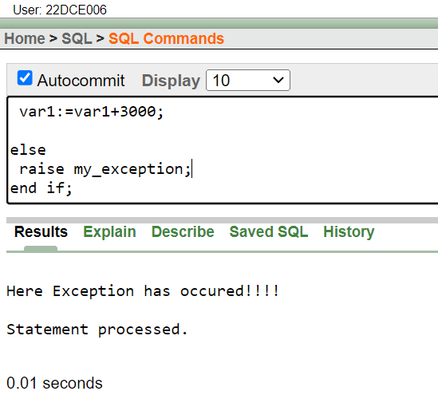

**Conclusion:** From this practical I learned the concept of exception handling using PL/SQL block.

**Staff Signature:**

**Grade:**

**Remarks by the Staff:**

**Practical 16**

**Aim: To perform the concept of trigger**

Write a PL/SQL block to update the salary where deptno is 10. Generate trigger that will store the original record in another table before updation take place.

**Query:**

create table emp_dummy(emp_no number , e_name varchar2(10),oldSalary number , newSalary number);

create or replace trigger trigger_used

before update on employee

for each row

when (new.dept_no = 10)

begin

insert into emp_dummy (emp_no, e_name, oldSalary, newSalary)

values (:old.emp_no, :old.emp_name, :old.emp_sal, :new.emp_sal);

end;

update employee SET emp_sal = 10000 WHERE emp_no = 105 AND dept_no = 10;

update employee SET emp_sal = 5000 WHERE emp_no = 105 AND dept_no = 10;

update employee SET emp_sal = 5000 WHERE emp_no = 106 AND dept_no = 10;

Select * from emp_dummy;

**Output:**

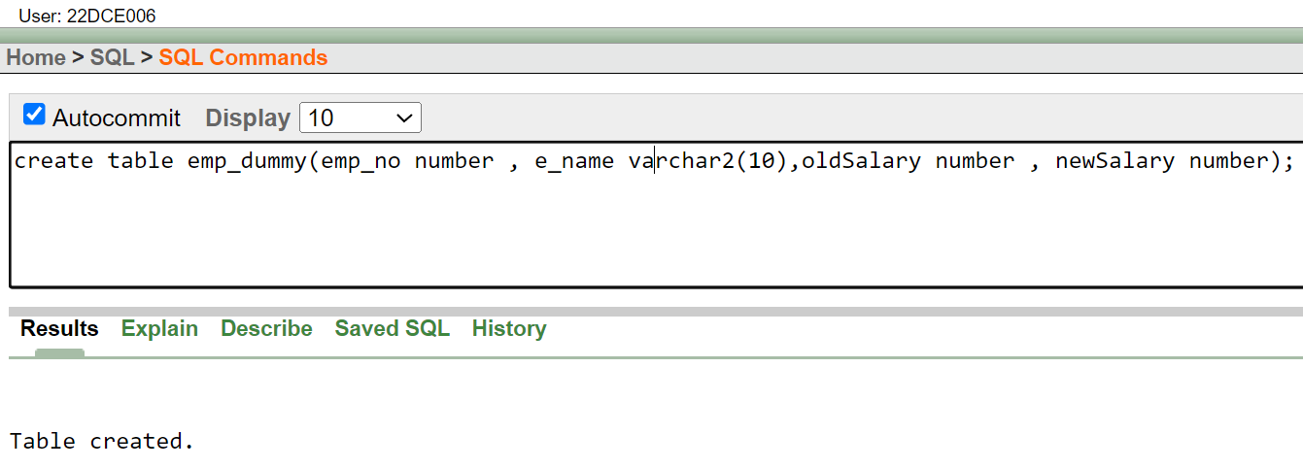

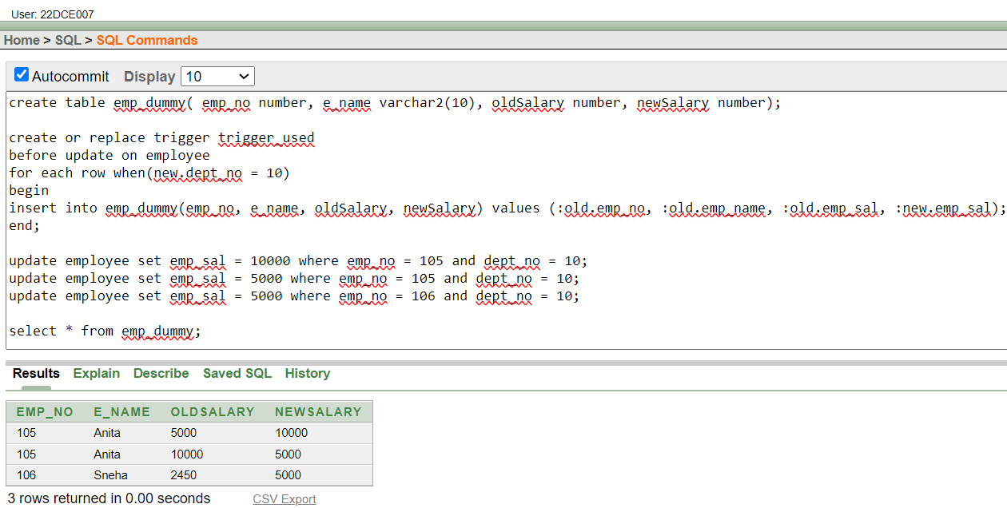

**Conclusion:** From this practical I learned the concept of triggers in PL/SQL

**Staff Signature:**

**Grade:**

**Remarks by the Staff:**

**Practical 17**

**Aim: To perform the concept of package**

**1. Create a package specification and package body called EMP_PACK that contains your NEW_EMP procedure as a public construct, and your VALID_DEPTID function as a private construct. (You can save the specification and body into separate files.)**

**2. Invoke the NEW_EMP procedure, using 40 as a department number. Because the dept_no 40 does not exist in the DEPT table, you should get an error message as specified in the exception handler of your procedure.**

**3. Invoke the NEW_EMP procedure, using an existing department ID 80.**

**i)Query-Output:**

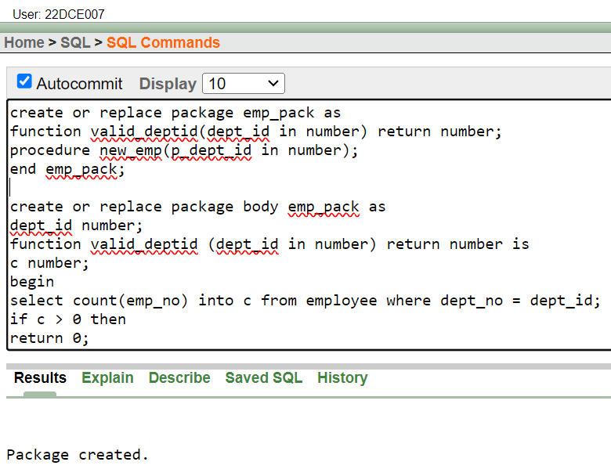

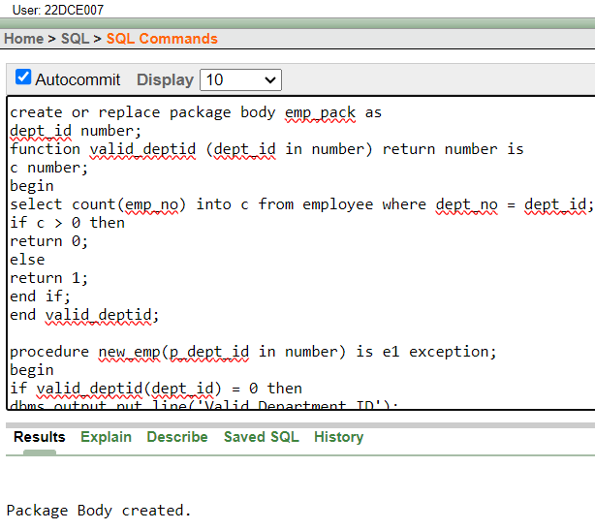

**ii)Query-Output:**

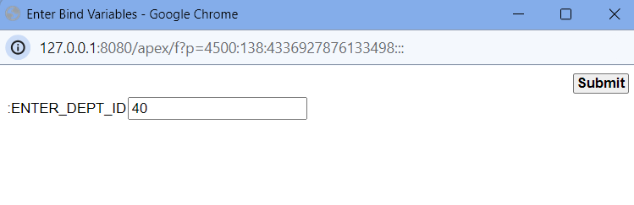

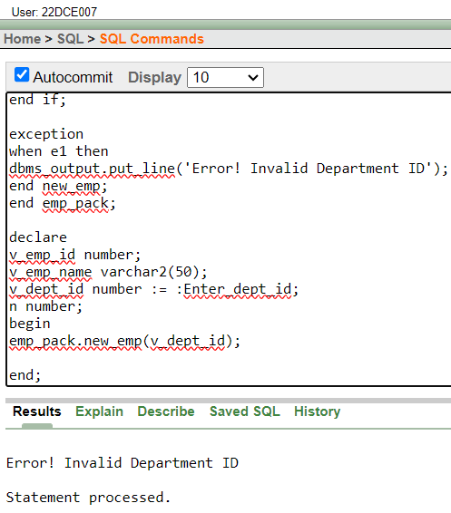

**iii)Query-Output:**

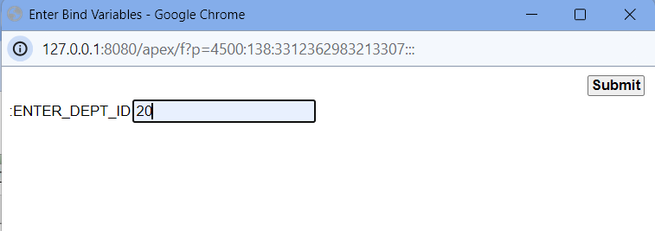

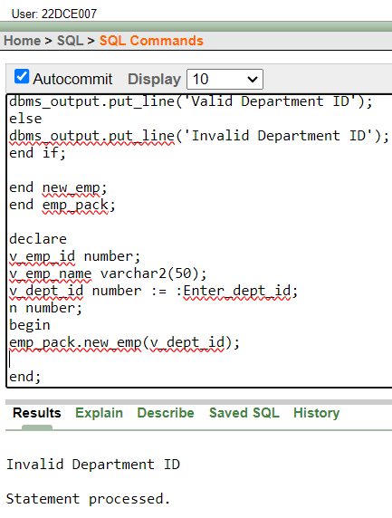

**Conclusion:** From this practical I learned the concept of Packages in PL/SQL.

**Staff Signature:**

**Grade:**

**Remarks by the Staff:**